FIFTEEN SHARDS OF LIGHT
Level_02 — Живой свет
BOUNDARY MAP, LAYER SPLIT AND ART PRODUCTION BIBLE
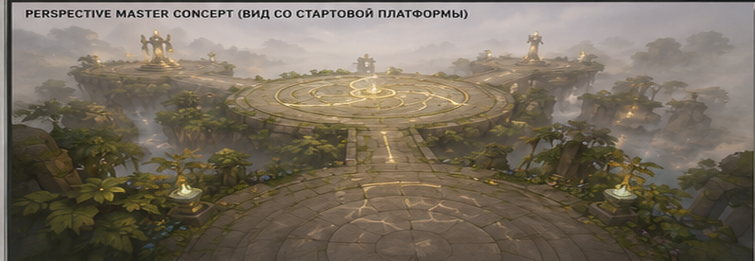
Blender production • Godot 4.x integration • Codex task source
Version 1.1 | 19 June 2026 | Art-production design candidate / no modeling included

Document Control
Field | Locked value
Project | Fifteen Shards of Light
Level | Level_02 — Живой свет
Document | Boundary Map, Layer Split and Art Production Bible
Status | ART-PRODUCTION DESIGN CANDIDATE
Pipeline | Blender → GLB/GLTF → Godot wrapper scenes → gameplay parent scenes
Scale | 1 Blender unit = 1 meter
Primary users | Environment Art, Blender Tech Art, Godot Integration, Producer, Codex Task Generator
Excluded | Final level modeling, final VFX, player character, Level_01 changes, Level_03 production, gameplay-layout changes

Version 1.1 Change Log
Correction | Version 1.1 resolution
Coordinate conventions | Blender +Z up, project-authored forward -Y; Godot +Y up, -Z forward after standard glTF conversion; no manual axis baking.
Gameplay ownership | RotationPivot, PetalPivot_01..04, BeamOrigin/Targets, PromptAnchor, receivers, ShardSpawnMarker and interaction nodes restored to gameplay scenes.
Fall recovery | Removed L02_FallSafety_Underlay_A. SoftReturnVolume remains authority; underside collision allowed only directly below visible walkable geometry.
Boundary openings | Locked 6.0 m minimum clear route openings: central ×3, arrival ×1, Trial A ×1, Trial B ×1.
Central ring split | Arena Rim = R20–22 physical/visual edge; Outer Ring = R18–20 decorative floor ring without collision.
Trial B petals | Positive-scale rotated instances only; mirrors must be applied in Blender and exported as explicit variants.
Naming | Trial platform assets renamed L02_Platform_Base_TrialA_A and L02_Platform_Base_TrialB_A; final suffix denotes variant only.
Codex handoff | Separated immediate greybox reference from POST-GREYBOX ART INTEGRATION SLICES; art slices forbidden in initial greybox PR.
Cleanup | Status revised, Stone_Tintable treated as shared shader variant, wrapper markers prefixed ArtAlignment_, wildcard GLB paths replaced, layout compacted.

Source-of-truth hierarchy and conflict resolution
This Bible consolidates three approved inputs. It does not redesign gameplay. When ranges or early concept values conflict with later exact specifications, the following hierarchy applies:
Priority | Authority
1. Gameplay Map and Level Design Spec v1.0 | Exact world coordinates, platform radii, routes, slope limits, clearances, timing and sightline acceptance.
2. Technical Architecture and State Model v1.1 | Scene ownership, NodePaths, wrapper boundaries, canonical IDs, controller responsibilities and portal/environment contracts.
3. Visual Master Concept Package v1.0 | Visual language, palette, silhouette direction, hero-asset families and forbidden art directions.
4. This Art Production Bible | Asset split, pivots, collision policy, budgets, materials, wrapper registry and export rules. It cannot override items 1–3.
5. AI concept-board imagery | Mood and silhouette reference only. Embedded labels and dimensions are non-authoritative.

Resolved production locks
Use central arena R22 physical / R20 usable; Arrival R10 / R8.5; Trial A and B R11 / R9.5; route width 5.5 m with ≥5.0 m visual clear width; hard slope maximum 8°; Trial A shell R2.1 × H4.2; Trial B bud R2.7 with pads at R5.0 and active diameter 2.3 m. These exact values supersede broader concept ranges.

Art production verdict
VERDICT — APPROVE A MODULAR, WRAPPER-FIRST ART PIPELINE
The level should be produced as a small set of gameplay-critical base/hero assets plus one restrained ruin kit and reusable foliage clusters. Geometry, collision, interaction pivots and VFX must remain separable. No imported GLB may own progression logic. Final Blender hero production remains gated by primitive greybox approval.

- Preserve the exact 1+3 platform layout and world transforms; art may break secondary symmetry, not gameplay coordinates.
- Create walkable bases and collision proxies before hero detail. Sightlines and route clearances are P0 art responsibilities.
- Use corrected Blender/Godot coordinate conventions, predictable mesh origins and gameplay-owned authoritative pivots so wrapper scenes can be swapped without gameplay rewiring.
- Separate emissive inserts from stone meshes; all sectors, spiral branches, petals and symbol inserts must be independently addressable.
- Limit unique materials and texture sets. Silhouette, readable scale and clean integration outrank micro-detail.

Document map
Section | Content
A | Boundary Map and clearances
B | Layer Split and ownership
C | Asset naming and complete modular registry
D | Budgets and LOD
E | Material family plan
F | Central Arena production sheet
G | Trial A production sheet
H | Trial B production sheet
I | Godot wrapper plan
J | Production order
K | Export checklist
L | Art acceptance criteria, risks and Codex handoff

A. Boundary Map
The boundary system is layered. Visible art communicates safety; invisible collision guarantees it; camera-safe and no-decoration zones preserve navigation. Every circular hard boundary contains explicit route-mouth openings of at least 6.0 m. SoftReturnVolume is the fall-recovery authority; no invisible catch floor may bridge gaps.
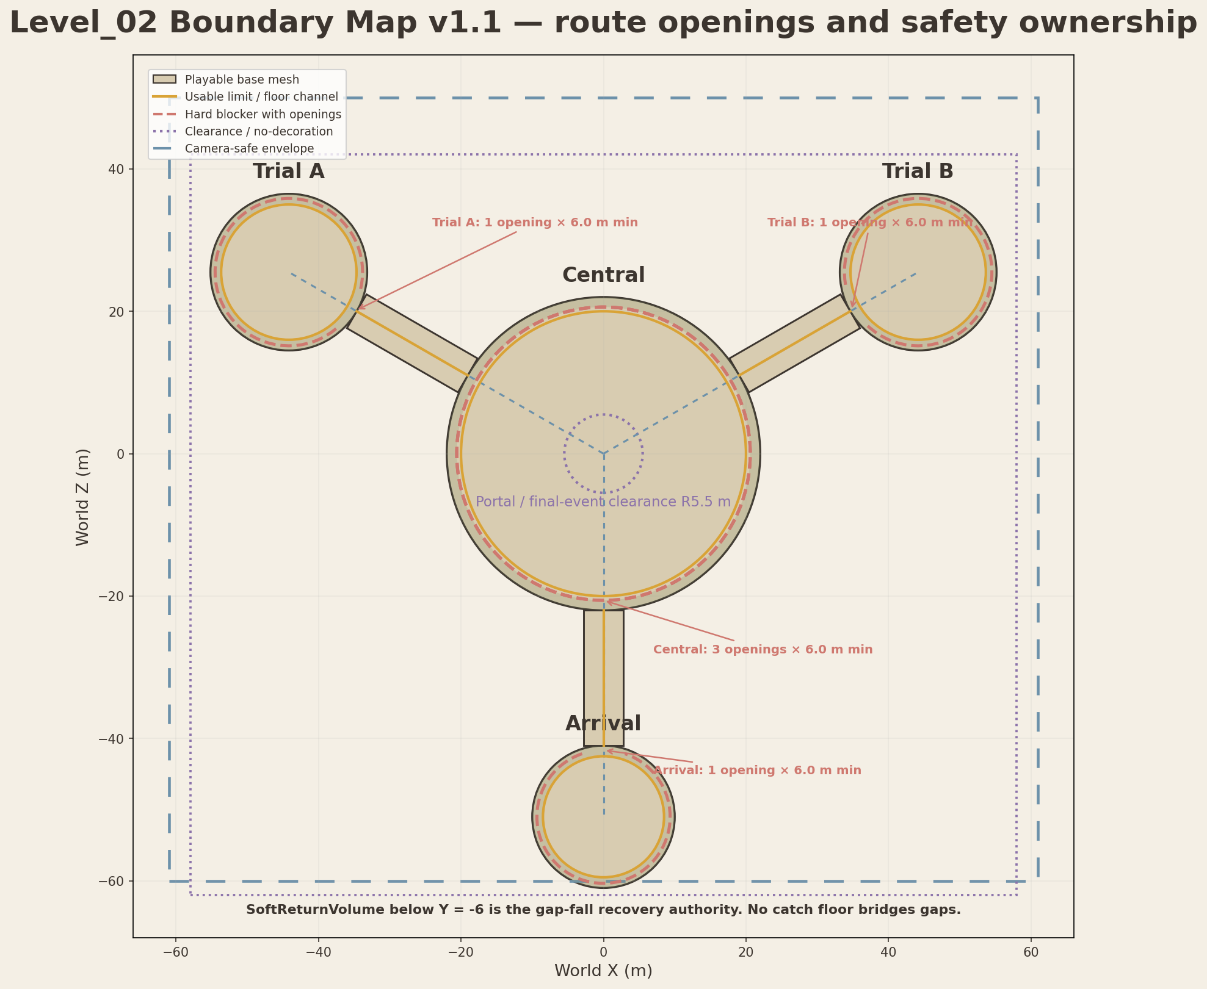
Figure A1. Consolidated production boundary map. Exact centers and radii follow the approved gameplay specification.
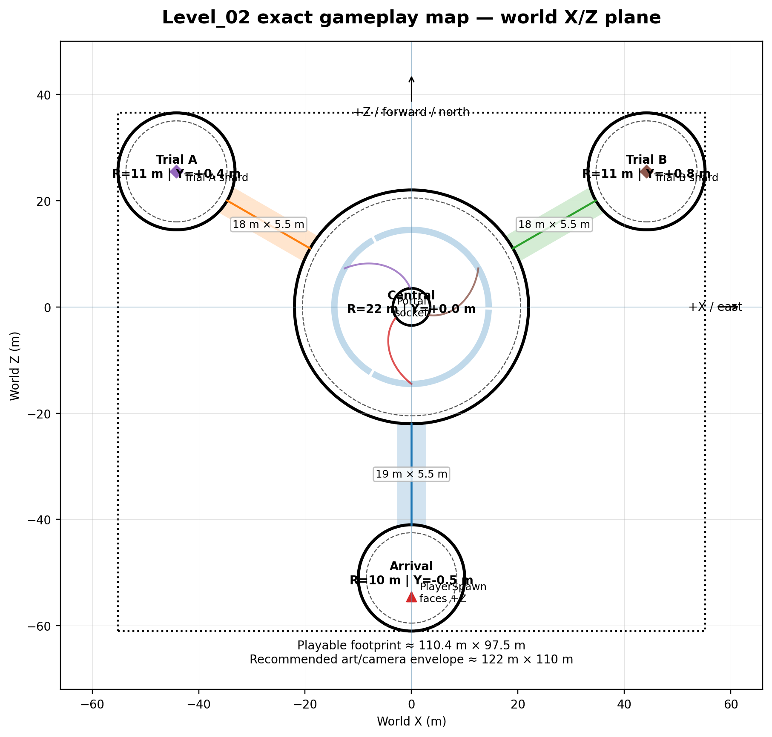
Figure A2. Approved exact gameplay map used as coordinate authority.
Boundary | Location | Dimensions | Collision | Visible | Production form | Owner / asset
Central playable surface | Center (0,0,0) | Disc R20.0 m usable; Y≈0 | StaticBody3D walkable proxy | Visible | Base mesh + separate collision GLB | L02_CentralArena_Base_A
Central physical rim | Around central surface | R20.0–22.0 m annulus; three route-mouth gaps ≥6.0 m | Visible rim + separate blocker arcs; gaps remain open | Visible | Separate rim modules | L02_CentralArena_Rim_A
Central hard boundary | Inside visual rim | Curved blocker at R≈20.6 m, interrupted by 3 openings ≥6.0 m | StaticBody3D box/convex segments | Invisible | Modular blocker arcs; never continuous across route mouths | Godot-owned collision
Arrival playable surface | Center (0,-51) | Disc R8.5 m usable | StaticBody3D walkable proxy | Visible | Base mesh + collision proxy | L02_Platform_Base_Arrival_A
Arrival hard boundary | Arrival rim | Curved blocker R≈9.35 m with 1 route opening ≥6.0 m | StaticBody3D segments | Invisible | Modular | Godot-owned collision
Trial A playable surface | Center (-44.17,25.50) | Disc R9.5 m usable | StaticBody3D walkable proxy | Visible | Base mesh + collision proxy | L02_Platform_Base_TrialA_A
Trial B playable surface | Center (44.17,25.50) | Disc R9.5 m usable | StaticBody3D walkable proxy | Visible | Base mesh + collision proxy | L02_Platform_Base_TrialB_A
Trial hard boundaries | Trial A/B rims | Curved blocker R≈10.35 m; one opening ≥6.0 m on each trial platform | StaticBody3D segments | Invisible | Shared modular blocker arcs with explicit route-mouth gap | Godot-owned collision
Arrival route | Central edge (0,-22) → Arrival edge (0,-41) | L19 × W5.5 m; clear W≥5.0 m | Walkable proxy + side blockers | Visible | Straight module + caps | L02_Path_Module_Straight_A
Trial A route | (-19.05,11) → (-34.64,20) | L18 × W5.5 m; clear W≥5.0 m | Walkable proxy + side blockers | Visible | Straight/transition modules | L02_Path_Module_Straight_A
Trial B route | (19.05,11) → (34.64,20) | L18 × W5.5 m; clear W≥5.0 m | Walkable proxy + side blockers | Visible | Straight/transition modules | L02_Path_Module_Straight_A
Soft visual boundary belt | All platform rims and route sides | Approx. 1.0–1.5 m dressing band | No collision except selected major props | Visible | Modular decor clusters | Rock/root/foliage families
Camera-safe art envelope | Around complete level | Approx. 122 × 110 m | None | Invisible guide | Godot/Blender guide only | Boundary reference mesh
Optional underside anti-tunneling collision | Only immediately below visible routes/platforms | Follows visible walkable geometry; never bridges gaps | Optional simplified StaticBody3D, local to walkable proxy | Invisible | Part of approved walkable collision; no standalone catch-floor asset | Walkable CollisionRoot; SoftReturnVolume remains recovery authority
SoftReturnVolume | Below complete level | Large Area3D below Y=-6 | Area3D; no visible mesh | Invisible | Godot-owned | Level02SoftReturnVolume
Decorative-only zone | Beyond hard blockers to camera envelope | Variable; no player access | No gameplay collision | Visible | Clusters, silhouettes | DECOR families

A.1 No-decoration corridors and interaction clearances
Clearance | Location | Hard rule
Route center corridors | All three routes | Keep full 5.0 m clear walking width; no roots, rocks or foliage protrusion above 0.08 m.
Tall-prop exclusion | Route centerlines | Props >1.8 m remain ≥3.5 m from route centerline.
Central choice sightlines | Annulus R10–18 m | No tall mass inside view cones toward both trial landmarks.
Portal / final-event clearance | Center (0,0,0) | No static obstruction in cylinder R5.5 m, H5.0 m; socket itself remains floor-integrated.
Portal trigger clearance | Center (0,1.7,0) | No collision inside R2.2 m, H3.4 m except disabled portal trigger.
Trial A shell clearance | Local center | No decor/collision within R3.2 m; shell physical R2.1 m.
Trial A statue interaction | Each statue | Clear player circulation radius 2.2 m; no prop blocks prompt or camera.
Trial A beam corridors | Statue BeamOrigin → receiver | Keep a visual cylinder ~0.6 m radius unobstructed; beam is VFX, not collision.
Trial A shard clearance | World (-44.17,2.0,25.5) | Clear cylinder R1.5 m, H4.0 m; no hidden collection collision before reveal.
Trial B bud clearance | Local center | No decor/collision within R3.4 m; physical bud R2.7 m.
Trial B symbol pads | Four centers at local R5.0 m | Active diameter 2.3 m; keep ≥1.5 m clear outside each pad edge.
Trial B outer camera ring | Trial B platform | Keep ≥2.0 m between pad edge and usable-platform boundary.
Trial B shard clearance | World (44.17,2.3,25.5) | Clear cylinder R1.5 m, H4.0 m.
Return route sightline | Each trial toward center | Do not block route opening or central socket/channel reference within 120° camera rotation.
Circular boundary openings | Central ×3; Arrival ×1; Trial A ×1; Trial B ×1 | Each clear opening ≥6.0 m. No blocker crosses route cap, connection channel or approved clear corridor.

B. Full Layer Split
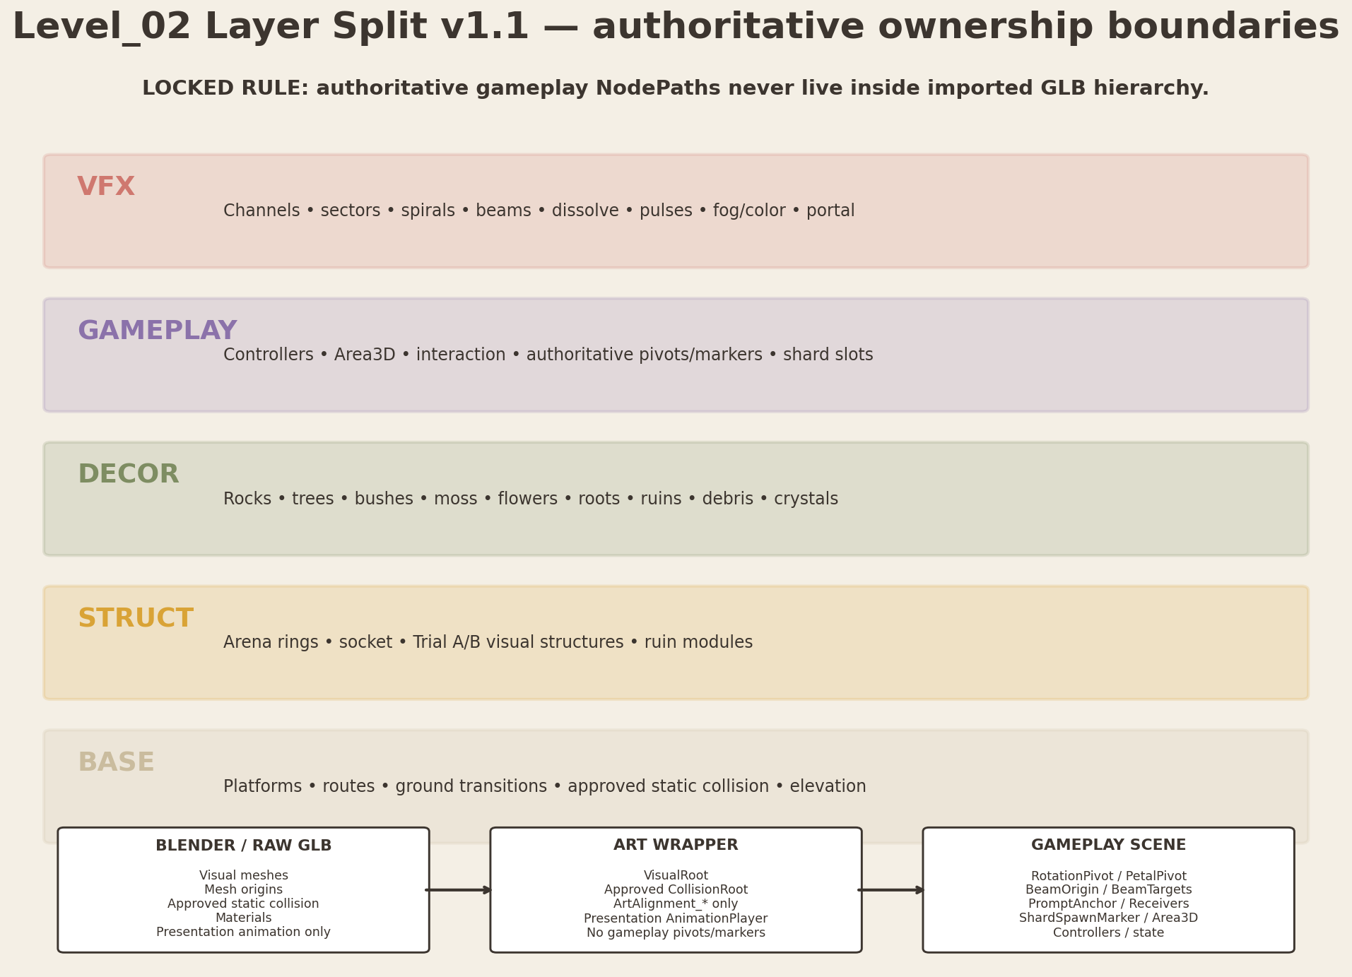
Figure B1. Layer ownership and replacement boundaries.
Layer | Element | Purpose | Production | Godot owner | Critical rule
BASE | Main platform terrain | Central/arrival/trial walkable bases. | Blender visual + simplified collision GLB | Block wrappers | No gameplay state.
BASE | Connecting paths | Straight/curved path modules, edge modules, transition caps. | Blender visual + simplified collision | Routes block | Clear W≥5.0 m.
BASE | Ground transitions | Stone-to-soil caps, elevation blends. | Mesh / vertex-color capable | Block wrappers | No collision detail below player scale.
BASE | Basic elevation | Approved platform Y offsets and slopes. | Transforms + base meshes | Level_02 block transforms | Hard max slope 8°.
BASE | Structural collision | Walkable and non-gameplay structural collision. | Separate proxy meshes / Godot primitives | CollisionRoot | Never derived from decorative detail.
STRUCT | Central arena rings | Outer ring, rim, three sector inserts. | Independent meshes | Central arena wrapper | Sectors separately addressable.
STRUCT | Central spiral branches | Three independent branch meshes. | Independent emissive-capable meshes | Central VFX/wrapper boundary | No progression logic in mesh.
STRUCT | Portal socket | Low floor-integrated socket. | Hero mesh + emissive insert | Portal socket wrapper | R3.5 m visual footprint.
STRUCT | Arrival circle | Start circle and route channel entry. | Mesh insert | Arrival wrapper | Start sector identity = arrival.
STRUCT | Trial A structures | Statue bases/bodies/heads, shell base/segments. | Hero modular family | Trial A wrappers | Head pivot exact.
STRUCT | Trial B structures | Pad bases, symbol inserts, bud base, petals, progress ring. | Hero modular family | Trial B wrappers | Four petals independent.
STRUCT | Ancient ruins | Curved wall, broken arc, short pillar, edge cap. | One modular ruin kit | Decor/structure wrappers | Break secondary symmetry only.
DECOR | Rocks and roots | Boundary communication and silhouette breakup. | Reusable props/clusters | Foliage/DressingRoot | No route blocking.
DECOR | Trees / bushes | Asymmetric massing and depth. | Reusable clusters | FoliageRoot | Major trunks only may collide.
DECOR | Moss / flowers | Surface softness and color return support. | Atlas/decal/mesh cards | DressingRoot | No small-foliage collision.
DECOR | Debris / light crystals | Localized storytelling and light accents. | Small props | DressingRoot | Crystals never compete with Soul Shard.
GAMEPLAY | Statue interactors | Area3D, prompt, fixed yaw controller. | Godot gameplay scene; visual wrapper instanced below VisualAnchor | TrialA_BeamStatue scene | Script on parent gameplay node.
GAMEPLAY | Beam origins and targets | Authoritative BeamOrigin/BeamTargets; visual emitter alignment | Godot-owned Marker3D in gameplay scene; ArtAlignment_* only in wrapper | Trial A gameplay scene / VFX adapter | Beam itself VFX.
GAMEPLAY | Symbol pads | Area3D and symbol identity. | Godot-owned Area3D and symbol identity; wrapper supplies visual pad only | TrialB_SymbolPad | Visual insert separate.
GAMEPLAY | Petal controls | Four pivot nodes and state commands. | Godot-owned PetalPivot_01..04 parents; visual petal mesh children | Trial B gameplay | Petal mesh child only.
GAMEPLAY | Shard spawn and holder visuals | Authoritative ShardSpawnMarker and hidden/reveal slot | Godot gameplay scene; optional non-authoritative art alignment in wrapper | Level02ShardSlot | No collection logic in art.
GAMEPLAY | Portal zone | Disabled trigger and adapter. | Godot-owned | Level02PortalAdapter | Visual and trigger separate.
VFX | Floor channels / sectors | Emission and flow presentation. | Mesh inserts + shader/VFX | Central/arrival/trial VFX scenes | Independent activation.
VFX | Trial A beams / shell dissolve | Beam VFX and reveal particles. | VFX-only | Level02TrialAVFX | Fallback-safe.
VFX | Trial B pulses / petal glow | Cue pulses, ring feedback, shard reveal. | VFX-only | Level02TrialBVFX | No input authority.
VFX | Environment transition | Saturation, fog and supporting particles. | WorldEnvironment/controller | Level02EnvironmentState/VFX | No duplicated gray materials.
VFX | Final beam / portal | Vertical beam, condensation and portal. | VFX-only + socket mesh | PortalVFX | Trigger remains separate.

C. Naming, scale, axes and file layout
Rule | Locked convention
Scale | 1 Blender unit = 1 meter; Scene Units Metric, Unit Scale 1.0.
Blender source axes | +Z up; project-authored forward = -Y. Do not manually axis-bake geometry to imitate Godot.
Godot import axes | +Y up; -Z forward after standard GLB/glTF conversion. Verify scale, orientation and pivots in a Godot import test scene.
Transform/export | Apply rotation and scale before export; exported object scale 1,1,1; no negative scale on interactive visual assets.
Mesh origin vs gameplay pivot | Raw GLB owns mesh origin only. RotationPivot/PetalPivot and all authoritative gameplay markers are authored in gameplay scenes.
Canonical files | Source: art/blender/level_02/{category}/L02_<Name>_<Variant>.blend; raw: assets/levels/level_02/{category}/L02_<Name>_<Variant>.glb; wrapper: scenes/environment/level_02/{category}/L02_<Name>_<Variant>.tscn.
Wrapper/block rule | Wrappers own VisualRoot, approved static CollisionRoot, optional presentation AnimationPlayer and ArtAlignment_* markers. Block scenes compose wrappers; no puzzle logic.
Variants and identity | Final _A/_B suffix always means true asset variant. TrialA/TrialB identity belongs in the asset stem. Rotated instances retain positive scale; explicit mirrored geometry is a separate Blender-exported variant.
Collision naming | Use separate _COL export or explicit wrapper collider only when justified. No complex automatic collision for interactive moving parts; no gap-spanning catch floor.

C.1 Complete Modular Asset Registry — BASE and STRUCT
Budgets are starting targets, not mandatory quotas. Dimensions are bounding-box production targets and may vary only after a documented review that preserves gameplay clearances.
Canonical asset | Purpose | Dimensions | Pivot / orientation | Modularity | Triangles | Texture / material | Emission slots | Collision / LOD | Blender folder | Wrapper folder | Priority
L02_CentralArena_Base_A | Walkable central disc | Ø44 × H0.8 | Origin center/ground; Blender -Y toward arrival; verify Godot -Z forward | Unique hero base | 12–20k | 2K; Stone_Warm | 0 | Custom COL; LOD1 | art/blender/level_02/base/ | scenes/environment/level_02/base/ | P0
L02_CentralArena_Rim_A | Outer physical/visual edge | R20–22 annulus; 3 route openings ≥6.0 m | Center/ground | Modular 30°–60° sections preferred | 6–12k total | 1K–2K; Stone/Moss | 0 | Separate blocker arcs; LOD1 | .../base/ | .../base/ | P0
L02_Platform_Base_Arrival_A | Arrival platform | Ø20 × H0.7 | Center/ground; Blender -Y toward route exit; verify Godot import | Unique size | 6–12k | 1K–2K; Stone/Soil | 0 | Custom COL; optional LOD1 | .../base/ | .../base/ | P0
L02_Platform_Base_TrialA_A | Trial A platform | Ø22 × H0.8 | Center/ground; Blender -Y toward route entry; verify Godot import | Shared base shape with B allowed | 7–14k | 1K–2K; Stone/Soil | 0 | Custom COL; optional LOD1 | .../base/ | .../base/ | P0
L02_Platform_Base_TrialB_A | Trial B platform | Ø22 × H0.8 | Center/ground; Blender -Y toward route entry; verify Godot import | Shared base shape with A allowed | 7–14k | 1K–2K; Stone/Soil | 0 | Custom COL; optional LOD1 | .../base/ | .../base/ | P0
L02_Path_Module_Straight_A | Primary route segment | L6 × W5.5 × H0.5 | Pivot center/ground; Blender -Y along module length | Highly modular | 2–5k | 1K; Stone/Soil | 0–1 | Box/custom COL; no LOD | .../base/ | .../base/ | P0
L02_Path_Module_Curve_30_A | Gentle route curvature | Arc R8–12; W5.5 | Pivot at arc center/ground | Modular 30° | 2–6k | 1K; Stone/Soil | 0–1 | Custom COL; no LOD | .../base/ | .../base/ | P0
L02_Path_Transition_Cap_A | Platform↔route seam cap | L3 × W5.5 × H0.5 | Pivot at seam center | Reusable | 1–3k | 1K; Stone/Soil | 0–1 | Box/custom COL | .../base/ | .../base/ | P0
L02_Path_Edge_A | Visual edge / safety cue | L3 × W0.8 × H0.7 | Pivot at inner seam | Modular | 0.8–2.5k | 1K; Stone/Moss | 0 | Collision separate blocker | .../base/ | .../base/ | P0
L02_Ground_Transition_A | Stone-to-soil blend insert | L4 × W5.5 | Pivot center/ground | Reusable | 1–3k | 1K; Soil/Stone | 0 | No separate collision | .../base/ | .../base/ | P1
L02_CentralRing_Outer_A | Inner decorative floor ring | R18–20 annulus; no overlap with rim | Center/ground | 30°/60° modular sectors | 6–12k total | 1K–2K; Stone/Moss | 0 | No collision; optional LOD1 | .../central/ | .../central/ | P1
L02_CentralRing_Sector_A | One progress sector insert | Arc ~100°; R16–18 | Center/ground | 3 instances | 2–5k | 1K; LightChannel | 1 emissive | No collision; no LOD | .../central/ | .../central/ | P1
L02_SpiralBranch_A | One spiral light branch | R15→3.8; W0.35–0.65 | Center/ground | 3 instances/rotations | 1–3k | 1K; LightChannel | 1 emissive | No collision | .../central/ | .../central/ | P1
L02_PortalSocket_A | Floor-integrated portal socket | Ø7 × H0.45 | Center/ground | Unique hero | 8–16k | 2K; Stone + PortalSocket | 1–2 emissive | Simple ring COL only if needed; LOD1 | .../central/ | .../central/ | P1
L02_ArrivalCircle_A | Arrival activation circle | Ø7–9 × H0.15 | Center/ground | Unique insert | 2–5k | 1K; LightChannel | 1 emissive | No collision | .../central/ | .../central/ | P1
L02_TrialA_Statue_Base_A | Static statue foundation | Ø2.0 × H0.55 | Center/ground; Blender -Y inward | 3 instances | 2–5k | 1K; Stone | 0 | Cylinder/convex COL | .../trial_a/ | .../trial_a/ | P1
L02_TrialA_Statue_Body_A | Vertical statue body | W1.2 × D1.0 × H2.0 | Bottom center; Blender -Y inward | 3 instances | 3–8k | 1K–2K; Stone/Metal | 0–1 | Simple convex COL | .../trial_a/ | .../trial_a/ | P1
L02_TrialA_Statue_Head_A | Rotating lens head shell | Ø1.4 × H1.1 | Mesh origin at intended mechanical center; authoritative RotationPivot is Godot gameplay-owned | 3 instances | 4–10k | 1K–2K; Stone/Metal | 1 optional | No player collision or simple convex; LOD1 optional | .../trial_a/ | .../trial_a/ | P1
L02_TrialA_BeamEmitter_A | Lens/emitter insert | Ø0.7 × D0.2 | Mesh origin at emitter visual center; Blender -Y authored beam-forward | 3 instances | 1–3k | 1K; TrialA_Emitter | 1 emissive | No collision | .../trial_a/ | .../trial_a/ | P1
L02_TrialA_CentralColumn_A | Column base/core | Ø4.2 × H4.2 | Center/ground | Unique hero | 8–18k | 2K; Stone/Emitter | 1 emissive | Simple cylinder/segment COL | .../trial_a/ | .../trial_a/ | P1
L02_TrialA_RevealShell_Segment_A | One reveal shell segment | Arc 90°; R2.1 × H4.2 | Mesh origin at hinge reference; gameplay/presentation pivot authored outside GLB | 4 instances | 2–6k each | 1K; Stone/Petal-like emissive | 1 emissive | No player collision during reveal | .../trial_a/ | .../trial_a/ | P1
L02_TrialB_SymbolPad_Base_A | Shared floor-pad base | Ø2.3 × H0.18 | Center/ground | 4 instances | 1–3k | 1K; Stone/LightChannel | 1 emissive | Walkable visual; gameplay Area separate | .../trial_b/ | .../trial_b/ | P1
L02_TrialB_SymbolInsert_Leaf_A | Leaf symbol insert | Fits Ø1.5 | Center/ground; Blender -Y toward entry | Variant | 0.5–1.5k | 512–1K; TrialB_Symbol | 1 emissive | No collision | .../trial_b/ | .../trial_b/ | P1
L02_TrialB_SymbolInsert_Sun_A | Sun symbol insert | Fits Ø1.5 | Center/ground | Variant | 0.5–1.5k | 512–1K; TrialB_Symbol | 1 emissive | No collision | .../trial_b/ | .../trial_b/ | P1
L02_TrialB_SymbolInsert_Wave_A | Wave symbol insert | Fits Ø1.5 | Center/ground | Variant | 0.5–1.5k | 512–1K; TrialB_Symbol | 1 emissive | No collision | .../trial_b/ | .../trial_b/ | P1
L02_TrialB_SymbolInsert_Star_A | Star symbol insert | Fits Ø1.5 | Center/ground | Variant | 0.5–1.5k | 512–1K; TrialB_Symbol | 1 emissive | No collision | .../trial_b/ | .../trial_b/ | P1
L02_TrialB_CentralBud_Base_A | Bud base/core | Ø5.4 × H1.1 | Center/ground | Unique hero | 6–14k | 2K; Stone/Petal | 1 emissive | Simple cylinder COL | .../trial_b/ | .../trial_b/ | P1
L02_TrialB_Petal_A | One controllable petal | L3.0 × W2.0 × T0.25 | Mesh origin at hinge reference; Blender +Z up, -Y authored outward reference | 4 rotated instances, positive scale only; explicit Blender mirror variant if required | 3–8k | 1K–2K; Petal | 1 emissive | No collision or tiny convex | .../trial_b/ | .../trial_b/ | P1
L02_TrialB_ProgressRing_Sector_A | One 1/4 progress ring insert | 90° arc; R3.0–3.8 | Center/ground | 4 instances | 0.8–2k | 1K; LightChannel | 1 emissive | No collision | .../trial_b/ | .../trial_b/ | P1
L02_TrialB_ShardHolder_A | Visual holder under bud | Ø0.8 × H0.8 | Center/ground | Unique small hero | 1–3k | 1K; Stone/Crystal | 1 optional | No collision | .../trial_b/ | .../trial_b/ | P1
L02_Ruin_CurvedWall_A | Low curved ruin wall | L4 × W0.7 × H1.2 | Pivot seam center | Modular | 2–6k | 1K; Stone/Moss | 0 | Box/convex if blocking; LOD1 optional | .../ruins/ | .../ruins/ | P2
L02_Ruin_BrokenArc_A | Broken non-monumental arch | W3.5 × D0.8 × H2.8 | Center/ground | Modular | 4–10k | 1K–2K; Stone/Moss | 0 | Convex/boxes; LOD1 | .../ruins/ | .../ruins/ | P2
L02_Ruin_Pillar_Short_A | Short softened pillar | Ø0.9 × H1.6 | Center/ground | Modular | 1–4k | 1K; Stone/Moss | 0 | Capsule/box | .../ruins/ | .../ruins/ | P2
L02_Ruin_EdgeCap_A | Platform edge ruin cap | L2.5 × W0.8 × H0.8 | Pivot seam center | Modular | 1–3k | 1K; Stone/Moss | 0 | No separate collision unless blocking | .../ruins/ | .../ruins/ | P2
L02_Ruin_StoneInset_A | Small floor/edge inset | L1.5 × W0.8 × H0.15 | Center/ground | Reusable | 0.4–1.5k | 512–1K; Stone | 0 | No collision | .../ruins/ | .../ruins/ | P2

C.2 Complete Modular Asset Registry — DECOR
Canonical asset | Purpose | Dimensions | Pivot | Reuse | Triangles | Texture/material | Collision/LOD | Priority
L02_Rock_Small_A | Small edge accent | 0.3–0.7 m | Bottom center | Reusable rotations | 0.3–1k | 512; Stone | None | P3
L02_Rock_Medium_A | Boundary mass | 0.8–1.6 m | Bottom center | Reusable | 0.8–2.5k | 1K; Stone/Moss | Simple convex only if blocking | P2
L02_Rock_Cluster_A | Soft visual boundary cluster | 2–4 m footprint | Cluster center/ground | Reusable | 2–6k | 1K; Stone/Moss | No collision or 1 coarse proxy | P2
L02_Tree_Small_A | Secondary vertical silhouette | H3–5 m | Trunk center/ground | Reusable variants | 1–4k | 1K atlas; Bark/Foliage | Capsule trunk optional; LOD1 | P2
L02_Tree_Medium_A | Primary secondary mass | H5–8 m | Trunk center/ground | Limited reuse | 2–8k | 1K–2K atlas | Capsule trunk; LOD1/LOD2 | P2
L02_Bush_Cluster_A | Low asymmetry cluster | 1.2–2.5 m | Cluster center/ground | Highly reusable | 0.3–1.5k | 512–1K foliage atlas | No collision | P3
L02_Bush_Cluster_B | Wide low cluster | 2–3.5 m | Cluster center/ground | Highly reusable | 0.5–2k | 512–1K foliage atlas | No collision | P3
L02_Root_Ground_A | Ground-hugging root | L2–4 m; H<0.35 | Root start/ground | Reusable | 0.8–3k | 1K; Bark/Moss | No collision in playable zones | P2
L02_Root_Arch_A | Boundary arch root | W2–3 × H1.5–2.5 | Center/ground | Limited | 2–6k | 1K; Bark/Moss | Convex if blocking; LOD1 optional | P2
L02_Moss_Patch_A | Surface breakup | 0.5–2 m | Center/ground | Atlas/decal | 0.1–0.8k | 512 atlas | No collision | P3
L02_Moss_EdgeStrip_A | Edge seam softening | L1–3 m | Seam start | Modular | 0.2–1k | 512 atlas | No collision | P3
L02_Flower_Cluster_A | Warm living accent | 0.3–0.8 m | Cluster center | Reusable | 0.1–0.7k | 512 atlas | No collision | P3
L02_Debris_Stone_A | Small ruin debris | 0.2–0.8 m | Bottom center | Reusable | 0.2–1.5k | 512; Stone | No collision unless >0.4 m high | P3
L02_LightCrystal_Small_A | Rare light mineral | H0.3–0.7 m | Bottom center | Reusable | 0.4–1.5k | 512–1K; Crystal | No collision | P2
L02_LightCrystal_Cluster_A | Hero-adjacent accent | 1–2 m footprint | Cluster center | Limited | 1.5–4k | 1K; Crystal/Stone | Simple convex optional | P2
L02_Background_Ruin_Silhouette_A | Non-playable depth mass | W5–10 × H3–6 | Center/ground | Limited | 2–8k | 1K; Stone/Moss | No collision; LOD1/LOD2 | P2

DECOR production path pattern
Blender: art/blender/level_02/decor/<asset>.blend • Raw GLB: assets/levels/level_02/decor/<asset>.glb • Wrapper: scenes/environment/level_02/decor/<asset>.tscn. Small no-collision foliage may share one wrapper scene with several mesh variants; do not merge all level decor into one GLB.

D. Asset Budget Guidelines
Category | Triangle target | Texture target | Collision | LOD | Examples
Hero structures | 8k–25k triangles per asset | 1K–2K; 2K only where justified | Simple custom collision proxy required | LOD1 for large or frequently visible heroes | Central socket, Trial A column/head, Trial B bud/petal family
Medium structures | 2k–10k | 1K–2K | Primitive or simplified custom collision | LOD1 optional beyond ~25–35 m | Ruin modules, statue bases/bodies, ring sections
Small props | 300–3k | 512–1K | Only when gameplay relevant | No LOD normally | Debris, crystals, roots, insets
Foliage | 100–2k | Shared 512–1K atlas | No collision for small foliage; capsule/box for major trunks | LOD1/LOD2 for trees | Bushes, moss cards, flowers, small trees
Walkable bases | 6k–20k visual; collision far lower | 1K–2K tiling/trim textures | Dedicated simplified walkable proxy | LOD rarely needed at level scale | Platforms and routes

- Budgets measure exported visible triangles, not Blender control cages or hidden high-poly sources.
- Bevels must support the approved soft silhouette, but subdivision should not be exported unless it produces visible value.
- Prefer trim sheets, atlases and tiling stone/soil materials over unique baked maps for every module.
- Transparency is restricted to small foliage and Trial B petals where justified; large stone surfaces remain opaque.

E. Material Family Plan
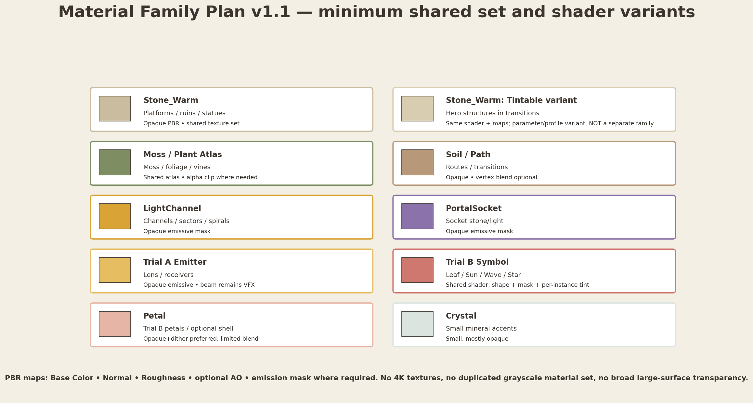
Figure E1. Minimum material family. The final implementation should remain close to this count.
Material | Purpose | Maps | Blend | Production notes | Uses
M_L02_Stone_Warm | Warm ancient stone | Base Color, Normal, Roughness, optional AO | Opaque | High roughness 0.65–0.9; warm beige; broad variation | Platforms, ruins, statue bodies
M_L02_Stone_Warm — Tintable shader variant | Shared Stone_Warm shader/profile for environment transitions | Same maps and texture set as Stone_Warm | Opaque | Not a separate material family; parameterized tint/desaturation compatibility only | Hero structures where local tint parameters are justified
M_L02_Moss_Atlas | Moss and plant growth | Base Color alpha, Normal, Roughness | Alpha clip for cards / opaque for mesh moss | Shared atlas; color remains alive in initial state | Moss, low plants, vines
M_L02_Soil_Path | Soft path / soil | Base Color, Normal, Roughness | Opaque | Vertex blend optional; no unique per-route material | Routes and transitions
M_L02_LightChannel | Floor channels and sectors | Base Color, Emission Mask, optional Normal | Opaque emissive | Ivory core + amber/peach halo via bloom/VFX | Channels, sectors, spirals
M_L02_PortalSocket | Portal socket stone/light | Stone maps + emission mask | Opaque emissive | Low inactive glow; final state controlled from Godot | Central socket
M_L02_TrialA_Emitter | Lens / beam emitter | Base Color, Normal, Roughness, emission | Opaque emissive | Warm core; beam not baked into material | Statue lenses and receivers
M_L02_TrialB_Symbol | Shared symbol shader | Base Color/Normal + emission mask | Opaque emissive | Per-instance tint and mask; shape remains primary cue | Leaf/Sun/Wave/Star inserts
M_L02_Petal | Trial B petals / shell accents | Base Color, Normal, Roughness, emission | Dither/alpha blend only if needed | Keep alpha area small; avoid sorting problems | Four petals / optional Trial A reveal shell
M_L02_Crystal | Light mineral accents | Base Color, Normal, Roughness, emission | Prefer opaque/transmission-lite | No large transparent volume | Small crystals only
Environment / fog support | Level-local Environment resource | N/A | WorldEnvironment | Saturation 0.20→1.00; fog ratios 1.00→0.92→0.55 | Not a mesh material

Material-state rule
Inactive/active states are driven by emission energy, tint and WorldEnvironment parameters. Do not duplicate the environment into separate gray material sets. All animated materials must be resource_local_to_scene or duplicated locally before runtime mutation.

F. Central Arena Production Sheet
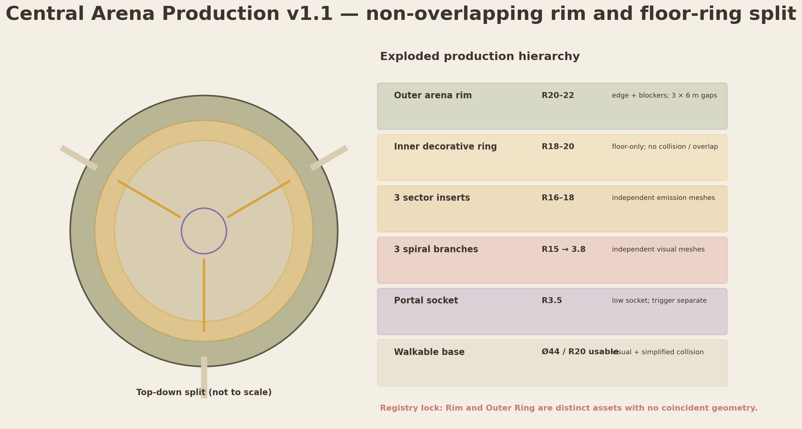
Figure F1. Central arena component split and exploded production hierarchy.
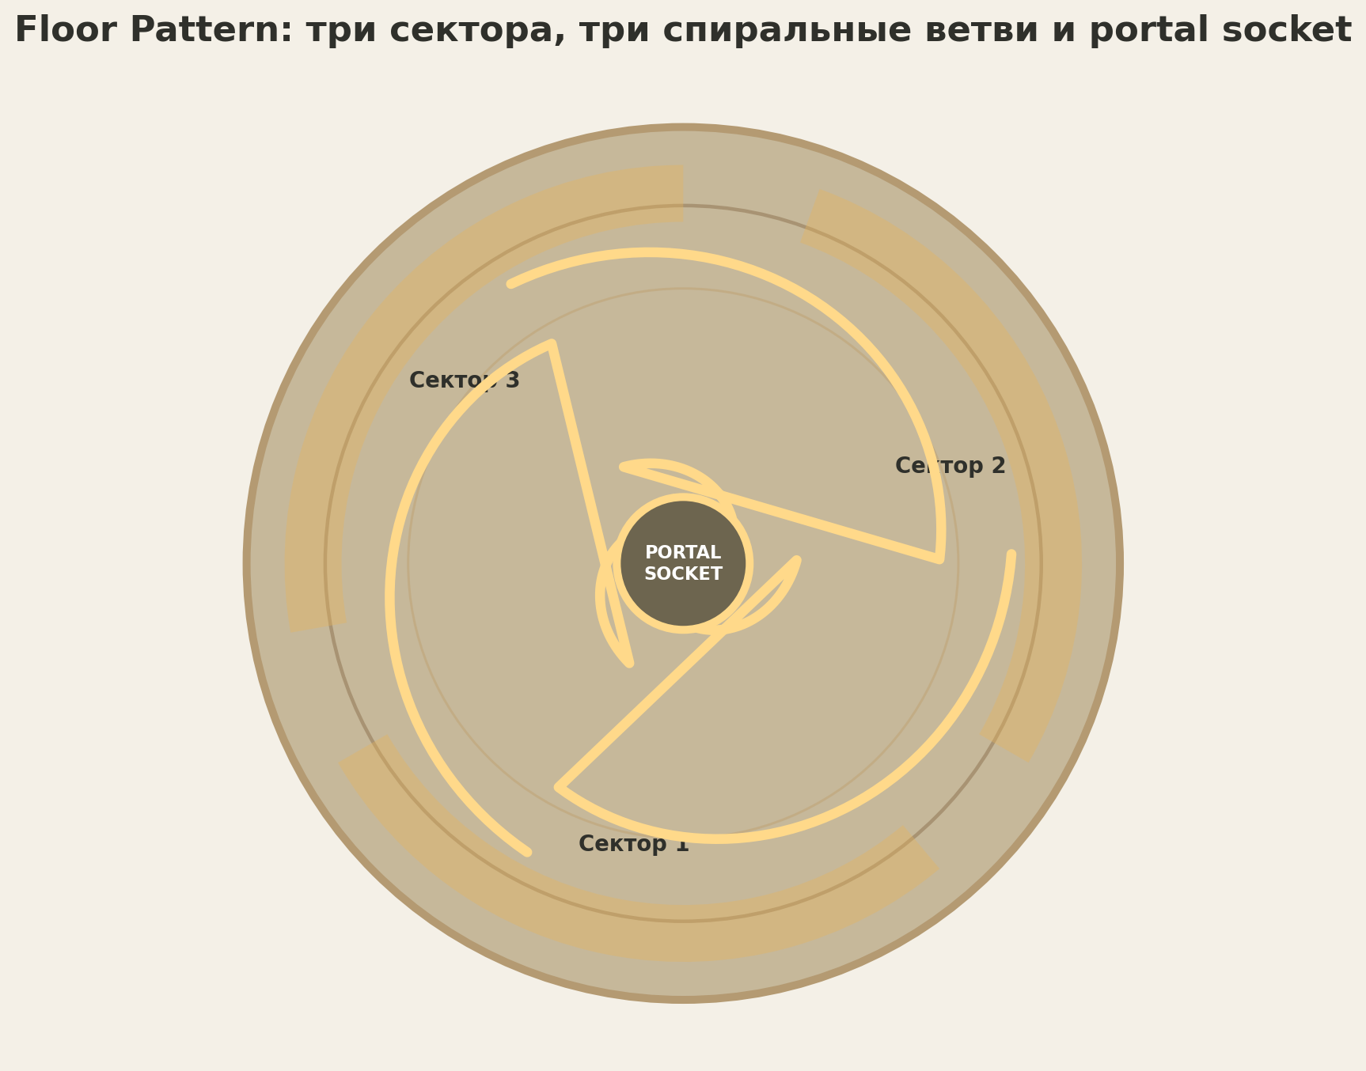
Figure F2. Approved floor-pattern visual reference: three sectors, three spiral branches and low portal socket.
Component | Asset / owner | Dimensions | Pivot / seam | Collision | Material/state
Walkable base | L02_CentralArena_Base_A | Ø44 m; usable R20 | Origin (0,0,0), ground plane | Dedicated simplified COL | Stone_Warm
Outer arena rim | L02_CentralArena_Rim_A | R20–22 annulus; three openings ≥6.0 m | Center/ground; modular blocker/visual seams outside route mouths | Separate blocker arcs; no collision across openings | Stone/Moss
Inner decorative outer ring | L02_CentralRing_Outer_A | R18–20 annulus | Center/ground; no coincident surface with rim | No collision | Stone/Moss; floor-only decoration
Sector inserts | 3× L02_CentralRing_Sector_A | R16–18; ~100° each | Common center pivot | No collision | LightChannel; independently addressable
Spiral branches | 3× L02_SpiralBranch_A | R15→3.8 | Common center pivot; rotated per identity | No collision | LightChannel; independent nodes
Portal socket | L02_PortalSocket_A | R3.5; H≤0.45 | Center/ground | Simple low ring collision only if needed | PortalSocket + stone
Connection channels | Mesh strips / VFX adapters | W0.25–0.6 along routes | Aligned to sector identities | No collision | LightChannel
Final beam | VFX-only | Approx. Ø0.25–0.5; H variable | PortalCenterMarker | No collision | VFX; no mesh requirement

F.1 Modular seams and state compatibility
- Sector and spiral meshes share the same local origin as the central base. Rotation instances must not introduce translation drift.
- Light-channel inserts are slightly raised or recessed by 0.01–0.03 m to avoid z-fighting without creating a player step.
- Inactive state remains readable through material roughness and shallow geometry; emissive is supportive, not the sole silhouette.
- All three identities map explicitly to arrival, trial_a and trial_b. Art hierarchy must not depend on child index.
- Outer ring decoration may break symmetry through modular ruin and moss placement, but the three central route mouths remain at least 6.0 m clear. The R20–22 arena rim and R18–20 decorative outer ring are non-overlapping assets.

G. Trial A Production Sheet — Three Beams
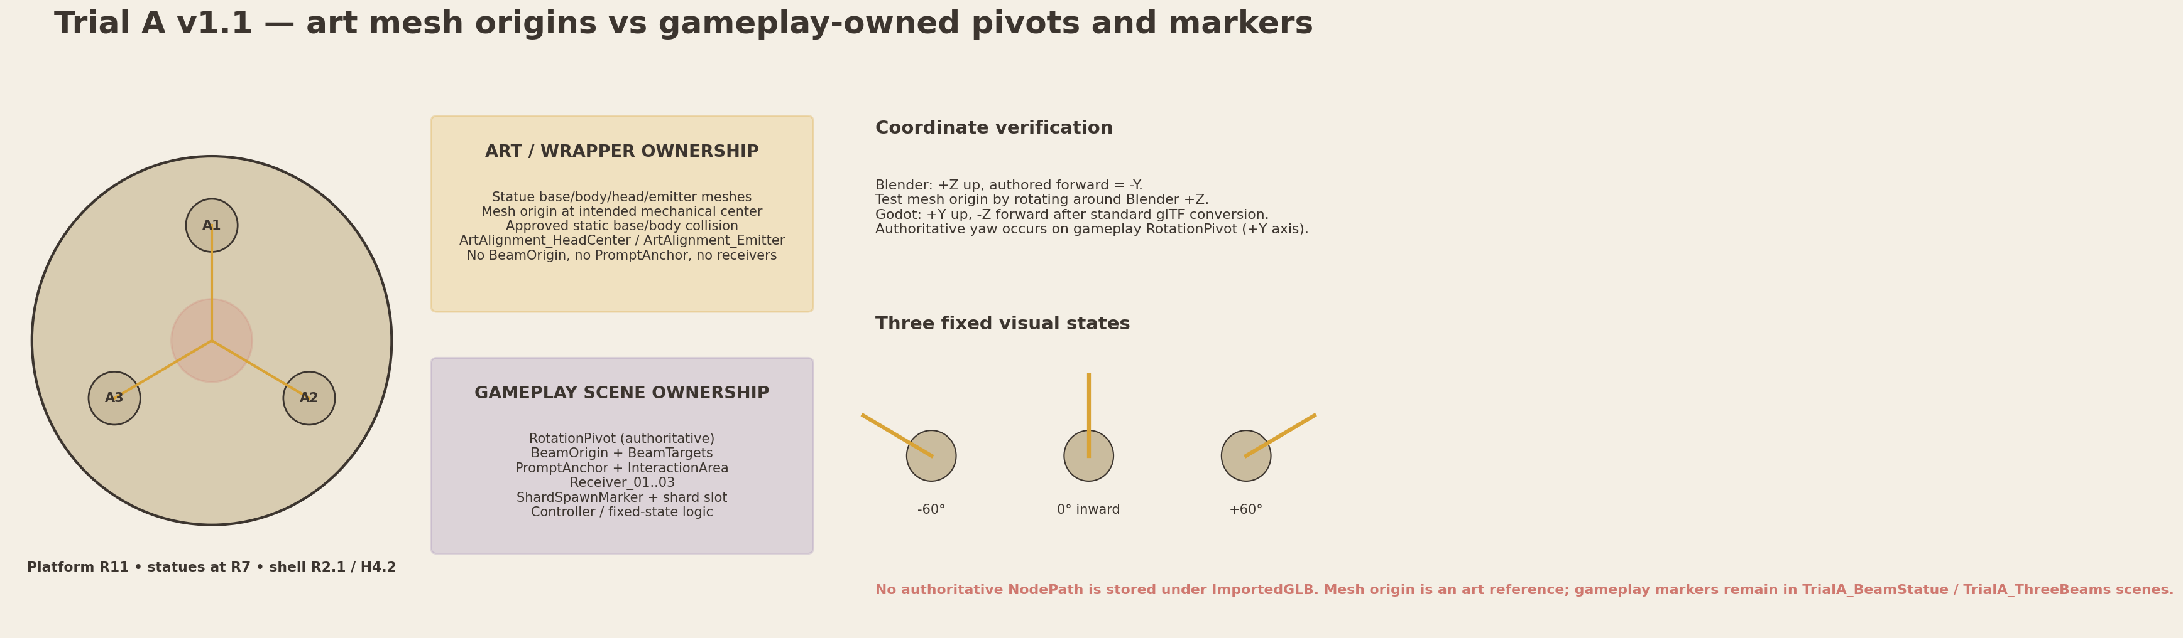
Figure G1. Trial A platform plan, statue pivot and fixed-orientation model.
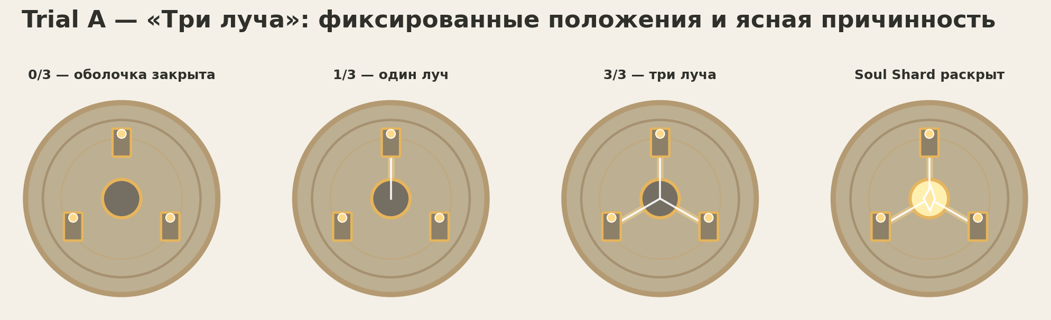
Figure G2. Approved visual-state sequence: 0/3, 1/3, 3/3 and Soul Shard reveal.
Element | Asset | Target size | Pivot/orientation | Collider | Critical production rule
Platform base | L02_Platform_Base_TrialA_A | Ø22; usable R9.5 | Center/ground | Walkable custom COL | Shared base language with Trial B
Statue base | L02_TrialA_Statue_Base_A | Ø2.0 × H0.55 | Center/ground | Static convex/cylinder | Does not rotate
Statue body | L02_TrialA_Statue_Body_A | Approx. H2.0 | Bottom center; Blender -Y inward | Static simple convex | May include non-rotating support
Rotation pivot | Godot gameplay RotationPivot | Exact mechanical yaw center | Exact mechanical yaw center; Godot +Y rotation axis | No collider on pivot | Authoritative gameplay node; wrapper/GLB does not own it
Rotating head | L02_TrialA_Statue_Head_A | Ø1.4 × H1.1 | Mesh origin aligned to yaw-center reference; rotation performed by gameplay pivot | No collision or small convex | States -60°, 0°, +60°
Beam emitter | L02_TrialA_BeamEmitter_A visual + gameplay BeamOrigin | Lens Ø0.7 | Blender -Y authored forward; Godot BeamOrigin Marker3D is authoritative | No collision | Emitter mesh separate from beam VFX; BeamOrigin/Targets remain gameplay-owned
Central column | L02_TrialA_CentralColumn_A | R2.1 × H4.2 | Center/ground | Coarse cylinder/segments | Open-top / segmented silhouette
Reveal shell | 4× L02_TrialA_RevealShell_Segment_A | R2.1 × H4.2 | Mesh origin at root reference; any controlling pivot lives outside imported GLB | No collision during reveal | Can dissolve/open independently
Shard holder | Optional visual holder + gameplay ShardSpawnMarker | World (-44.17,2.0,25.5) | Gameplay marker at world (-44.17,2.0,25.5) | No collision | ShardSpawnMarker and Level02ShardSlot are gameplay-owned

Critical ownership and pivot lock | The raw head GLB carries a mesh origin at the intended mechanical center only. Validate the source in Blender (+Z up) by rotating the mesh reference around Blender +Z through -60°, 0° and +60° without orbiting or drift. In Godot, the authoritative RotationPivot is created in TrialA_BeamStatue and rotates around +Y. BeamOrigin, BeamTargets, PromptAnchor, receiver markers and ShardSpawnMarker are authored exclusively in gameplay scenes. Wrappers may expose only non-authoritative ArtAlignment_HeadCenter and ArtAlignment_Emitter aids.

H. Trial B Production Sheet — Echo of Light
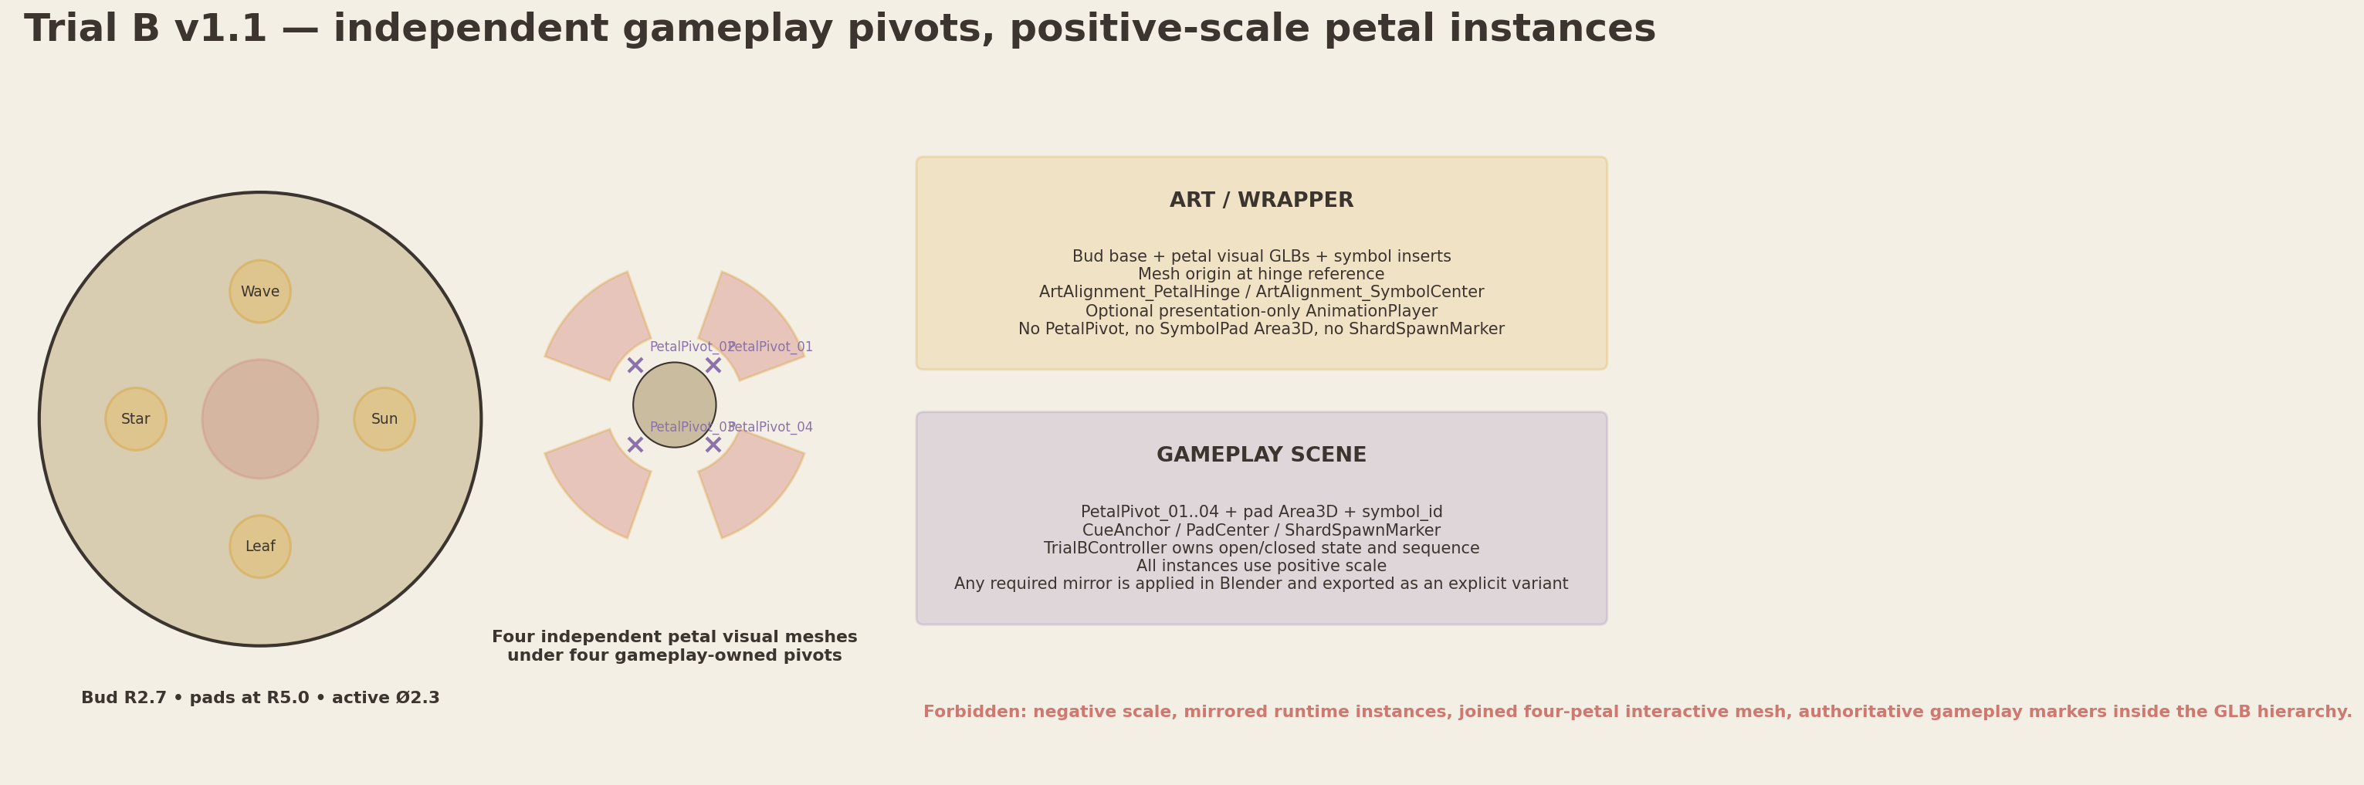
Figure H1. Trial B pad spacing, independent petal pivots and exploded component split.
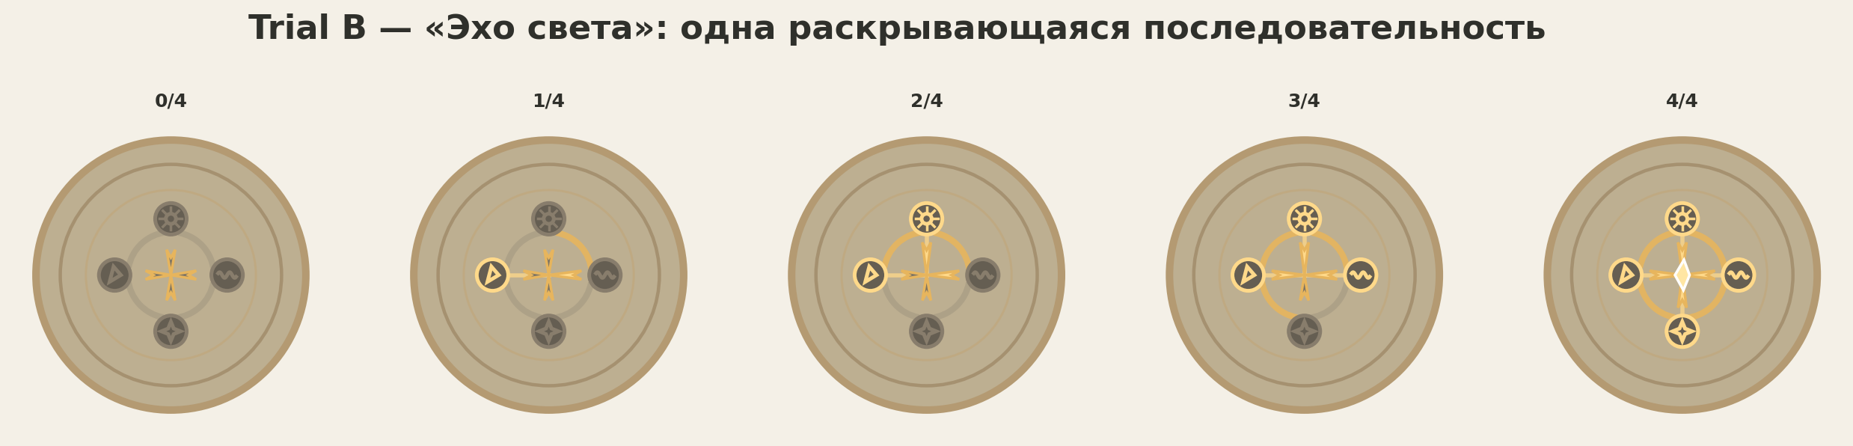
Figure H2. Approved cumulative visual states 0/4 through 4/4.
Element | Asset | Target size | Pivot/orientation | Collider | Critical production rule
Platform base | L02_Platform_Base_TrialB_A | Ø22; usable R9.5 | Center/ground | Walkable custom COL | Same material language as Trial A
Pad base | 4× L02_TrialB_SymbolPad_Base_A | Ø2.3 × H0.18 | Center/ground | No gameplay identity in mesh | Area3D and symbol_id remain Godot-owned
Symbol inserts | Leaf/Sun/Wave/Star variants | Fits Ø1.5 | Center/ground; same registration | No collision | Shape + internal pattern + color accent
Central bud base | L02_TrialB_CentralBud_Base_A | R2.7 × H≈1.1 | Center/ground | Simple cylinder/convex | Supports four hinge points
Petals | 4× L02_TrialB_Petal_A | Approx. L3 × W2 | Mesh origin at hinge reference; authoritative PetalPivot_01..04 are gameplay-owned | No player collision | Four positive-scale rotated instances. Negative scale forbidden; mirrored shape requires explicit Blender-exported variant.
Progress ring | 4× L02_TrialB_ProgressRing_Sector_A | R3.0–3.8 | Common center pivot | No collision | One sector per stage
Shard holder | L02_TrialB_ShardHolder_A visual / gameplay ShardSpawnMarker | Center, Y2.3 world | Gameplay marker at world Y2.3; art holder centered | No collision | ShardSpawnMarker is gameplay-owned; visibility at 3/4 is VFX/material only

H.1 Petal state, positive-scale instance and gameplay-pivot contract
- Each petal is a separate positive-scale visual mesh instance under a gameplay-owned PetalPivot_01..04. No joined four-petal mesh or negative-scale mirrored instance is allowed.
- Closed pose is the authored visual default. Open pose is driven by gameplay-owned pivots or an approved presentation adapter. Rotated instances use positive scale; any required mirror is applied in Blender and exported as an explicit variant.
- Petal geometry must not intersect the shard holder in any of the 0/4–4/4 states.
- Pads remain readable under desaturation by silhouette and internal relief; color is never the only differentiator.
- Progress-ring sectors and pad symbol emission are separate materials or meshes so cue/highlight states do not brighten the whole platform.

I. Godot Wrapper Plan
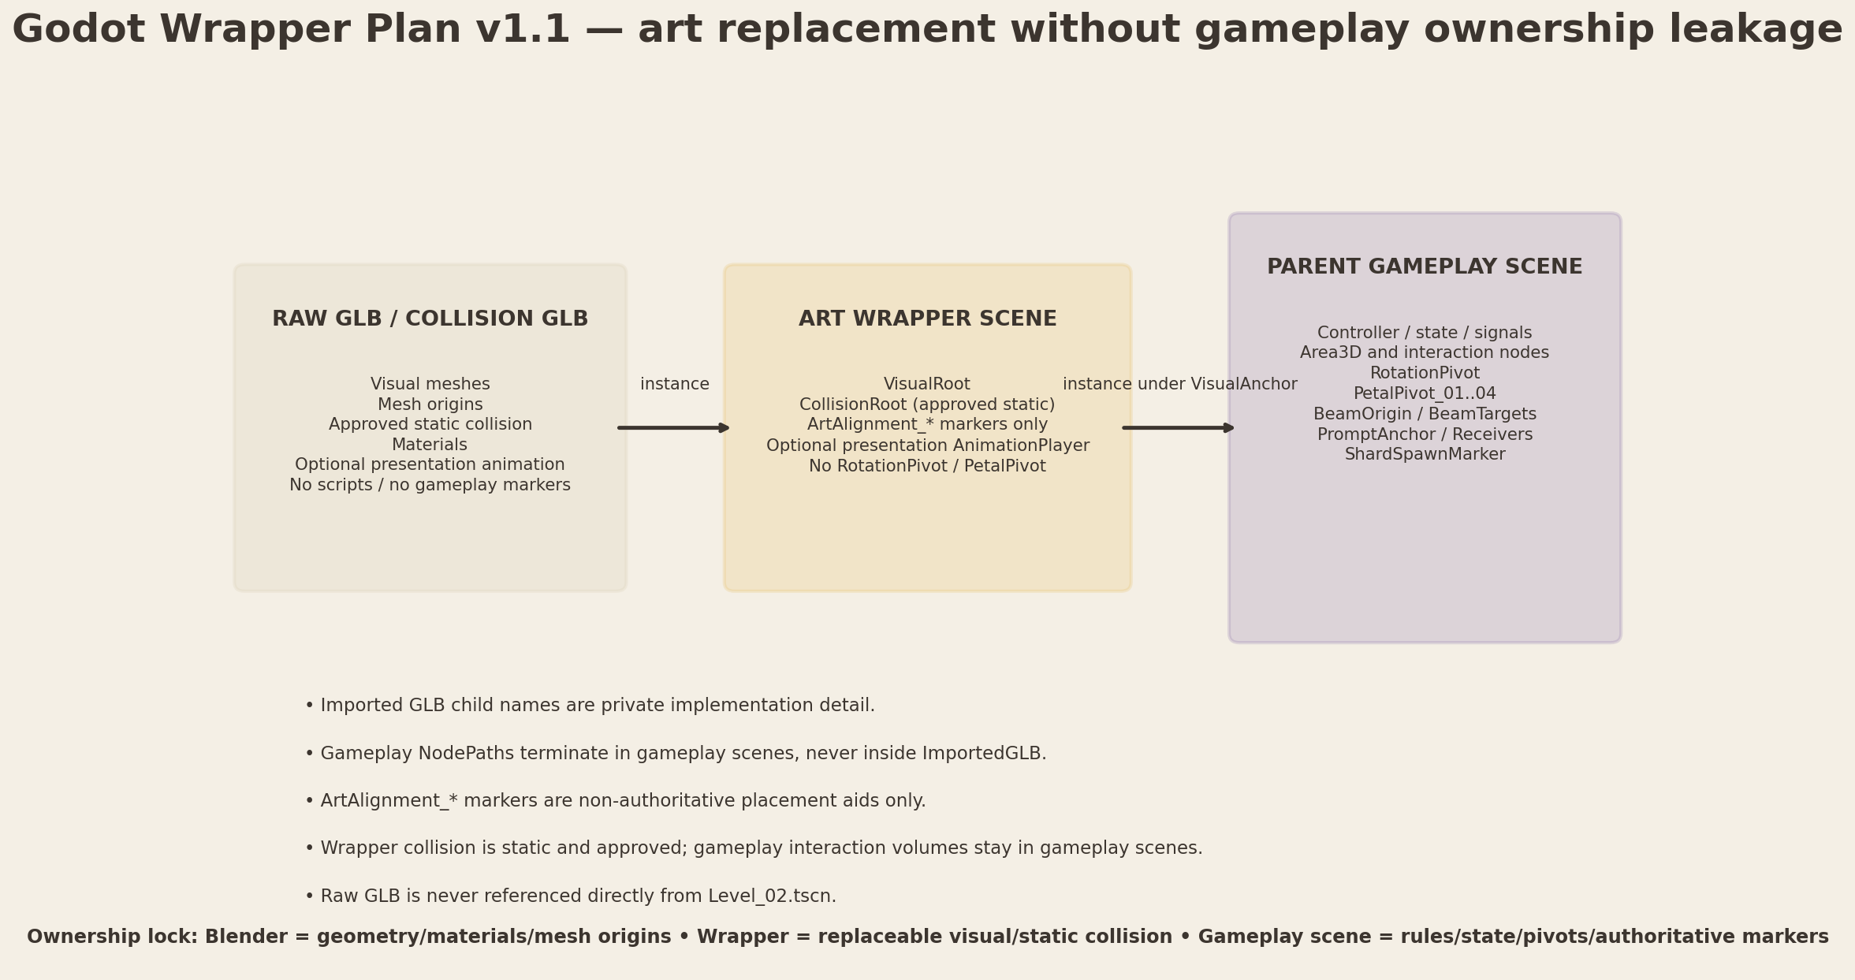
Figure I1. Stable integration boundary between raw assets, wrapper scenes and gameplay scenes.
Interactive visual | Raw GLB | Wrapper scene | Wrapper contents | Collision owner | Script / ownership rule
Central base | assets/levels/level_02/base/L02_CentralArena_Base_A.glb | scenes/environment/level_02/base/L02_CentralArena_Base_A.tscn | VisualRoot; CollisionRoot; ArtAlignment_Center; ArtAlignment_RouteMouth_* | StaticBody3D in wrapper | No script on GLB; gameplay markers remain in block/gameplay scenes
Central ring sector | assets/levels/level_02/central/L02_CentralRing_Sector_A.glb | scenes/environment/level_02/central/L02_CentralRing_Sector_A.tscn | VisualRoot; optional presentation AnimationPlayer; ArtAlignment_SectorCenter | None | Central VFX/controller references wrapper root, not imported child names
Spiral branch | assets/levels/level_02/central/L02_SpiralBranch_A.glb | scenes/environment/level_02/central/L02_SpiralBranch_A.tscn | VisualRoot; optional presentation AnimationPlayer; ArtAlignment_BranchRoot | None | Three positive-scale rotated instances with explicit identities
Portal socket | assets/levels/level_02/central/L02_PortalSocket_A.glb | scenes/environment/level_02/central/L02_PortalSocket_A.tscn | VisualRoot; ArtAlignment_PortalCenter | Optional low StaticBody3D | PortalCenterMarker and trigger remain Level02PortalAdapter-owned
Trial A statue | assets/levels/level_02/trial_a/L02_TrialA_Statue_Base_A.glb; L02_TrialA_Statue_Body_A.glb; L02_TrialA_Statue_Head_A.glb; L02_TrialA_BeamEmitter_A.glb | scenes/environment/level_02/trial_a/L02_TrialA_Statue_A.tscn | VisualRoot; approved base/body CollisionRoot; ArtAlignment_HeadCenter; ArtAlignment_Emitter | Base/body static collision in wrapper | RotationPivot, BeamOrigin/Targets and PromptAnchor live in TrialA_BeamStatue gameplay scene
Trial A column | assets/levels/level_02/trial_a/L02_TrialA_CentralColumn_A.glb; L02_TrialA_RevealShell_Segment_A.glb | scenes/environment/level_02/trial_a/L02_TrialA_CentralColumn_A.tscn | VisualRoot; optional static collision; ArtAlignment_Receiver_*; ArtAlignment_ShardVisual | Simple static collision | Receiver markers and ShardSpawnMarker live in TrialA_ThreeBeams gameplay scene
Trial B pad | assets/levels/level_02/trial_b/L02_TrialB_SymbolPad_Base_A.glb; L02_TrialB_SymbolInsert_Leaf_A.glb; L02_TrialB_SymbolInsert_Sun_A.glb; L02_TrialB_SymbolInsert_Wave_A.glb; L02_TrialB_SymbolInsert_Star_A.glb | scenes/environment/level_02/trial_b/L02_TrialB_SymbolPad_A.tscn | VisualRoot; ArtAlignment_SymbolCenter | None or approved visual walkable collision only | Area3D, PadCenter, CueAnchor and symbol_id remain in TrialB_SymbolPad gameplay scene
Trial B bud | assets/levels/level_02/trial_b/L02_TrialB_CentralBud_Base_A.glb; L02_TrialB_Petal_A.glb; L02_TrialB_ProgressRing_Sector_A.glb; L02_TrialB_ShardHolder_A.glb | scenes/environment/level_02/trial_b/L02_TrialB_CentralBud_A.tscn | VisualRoot; approved static center collision; ArtAlignment_PetalHinge_*; ArtAlignment_ShardVisual; optional presentation AnimationPlayer | Simple center static collision | PetalPivot_01..04 and ShardSpawnMarker live in TrialB_EchoOfLight gameplay scene
Ruin/rock/tree prop | assets/levels/level_02/ruins/L02_Ruin_CurvedWall_A.glb; assets/levels/level_02/decor/L02_Rock_Medium_A.glb; assets/levels/level_02/decor/L02_Tree_Small_A.glb | scenes/environment/level_02/ruins/L02_Ruin_CurvedWall_A.tscn; scenes/environment/level_02/decor/L02_Rock_Medium_A.tscn; scenes/environment/level_02/decor/L02_Tree_Small_A.tscn | VisualRoot; optional CollisionRoot; optional ArtAlignment_Placement | Only major blockers/trunks | One concrete asset per wrapper; no gameplay controller

I.1 Wrapper scene canonical structure — art-only ownership
Recommended pattern:
L02_<Asset>_<Variant> (Node3D)
├── VisualRoot (Node3D)
│ └── ImportedGLB (instance)
├── CollisionRoot (Node3D, optional approved static collision)
│ └── StaticBody3D / CollisionShape3D
├── ArtAlignmentMarkers (Node3D, optional, non-authoritative)
│ ├── ArtAlignment_Placement
│ └── ArtAlignment_<VisualFeature>
└── AnimationPlayer (optional presentation only)
Authoritative RotationPivot, PetalPivot_01..04, BeamOrigin/Targets, PromptAnchor, receivers, ShardSpawnMarker, Area3D and scripts live in the parent gameplay scene.

I.2 Collision ownership matrix
System | Collider type | Owner | Godot node | Rule
Walkable platforms/routes | Dedicated simplified mesh or primitive set | Wrapper CollisionRoot | StaticBody3D | Matches gameplay dimensions; ignores decorative chips/cracks. Optional underside thickness only directly below visible geometry; never bridges gaps.
Platform/rim blockers | Curved box/convex segments | Block scene or dedicated boundary wrapper | StaticBody3D | 0.35–0.60 m inside visual rim; explicit ≥6.0 m route openings; never crosses light channel or route cap.
Major ruin blockers | Box/convex proxies | Prop wrapper | StaticBody3D | Only when visually obvious and outside no-decoration corridors.
Trees | Capsule/box trunk only | Tree wrapper | StaticBody3D | Only major trunks; foliage has no collision.
Trial A rotating head | None or tiny convex if unavoidable | Statue wrapper | StaticBody3D child under pivot only if tested | Must not affect interaction or beam target.
Trial A/B interaction volumes | Godot primitive shapes | Gameplay scene | Area3D | Never exported from Blender.
Petals and VFX | None | N/A | N/A | No collision; presentation only.
Portal trigger | Godot capsule/cylinder | Level02PortalAdapter/PortalCore | Area3D | Disabled until formation completes.
Fall recovery | Large Godot Area3D below Y=-6 | GameplayRoot/SafetyRoot | Area3D | No visible mesh; preserves puzzle state.

J. Production Order
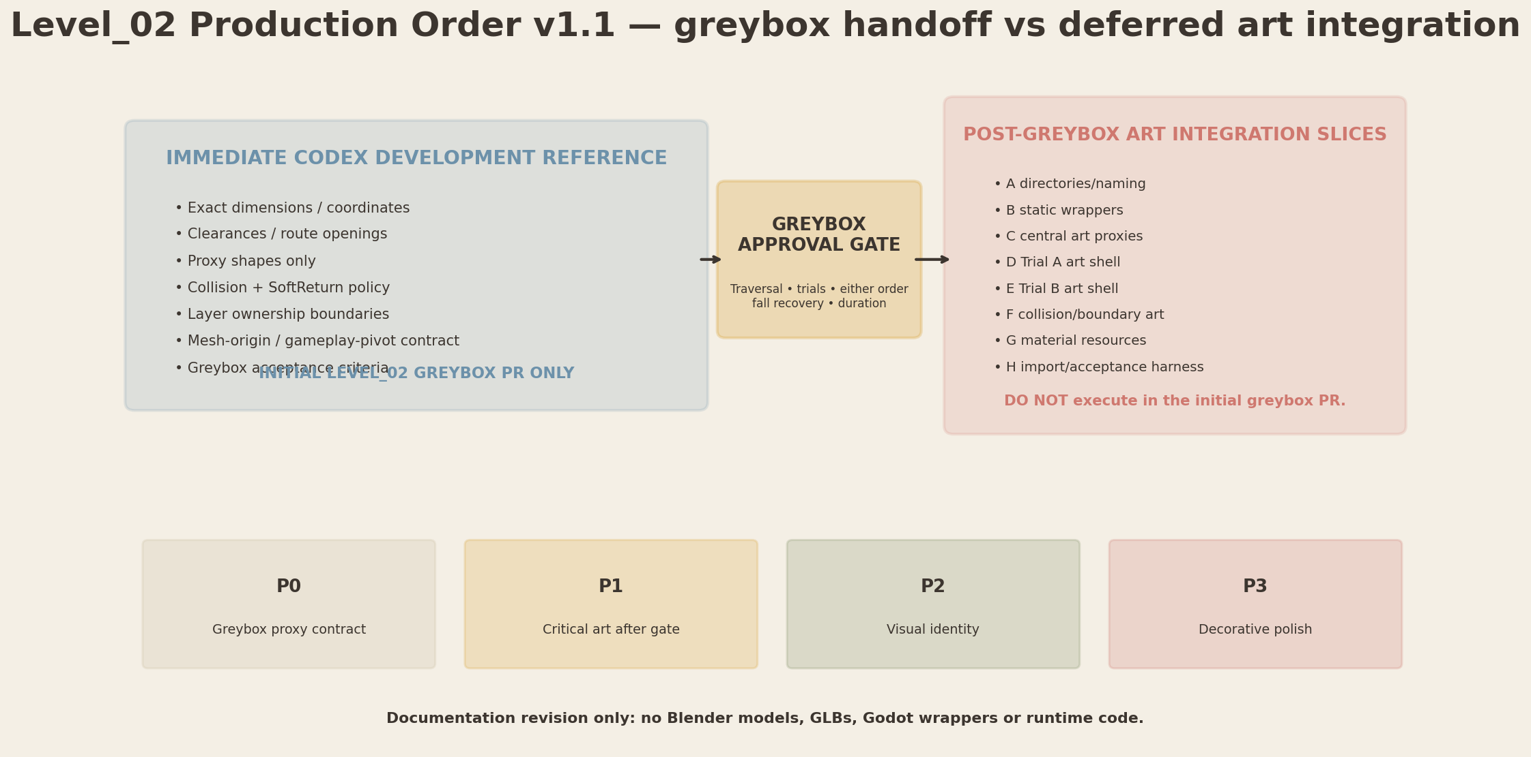
Figure J1. Priority order and approval gates.
Priority | Scope | Deliverables | Exit gate
P0 | Immediate greybox reference only | Dimensions; clearances; proxy shapes; collision policy; layer boundaries; gameplay pivot contracts; acceptance criteria. No Blender models, GLBs or art wrappers. | All coordinates within ±0.25 m; routes ≥5.0 m clear; sightlines pass; no final detail.
P1 | Post-greybox gameplay-critical art | Central sectors/branches/socket; Trial A visual assets; Trial B visual assets; wrappers after greybox approval. | Interactive pivots exact; parts independently addressable; wrappers test-import cleanly.
P2 | Visual identity | One ruin kit; boundary rocks; small/medium trees; roots; light crystals. | No route blocking; center not boss arena; trial silhouettes remain distinct.
P3 | Decorative filler and polish | Bushes, moss, flowers, debris, minor variation. | Performance budget, no sightline regression, no material explosion.

Hard production gate | Do not begin final hero modeling or execute art-integration slices until primitive-only traversal, both trials, either-order progression, fall recovery and target completion time pass. The initial Level_02 greybox PR may consume only dimensions, clearances, proxy shapes, collision policy, layer boundaries, pivot contracts and acceptance criteria.

K. Blender → GLB Export Checklist
Check | Acceptance
Scale | Scene units Metric; Unit Scale 1.0; exported dimensions match meters.
Transforms | Rotation and scale applied; object scale = 1,1,1; no negative scale on exported interactive assets.
Coordinate conversion | Blender +Z up and authored forward -Y; no manual axis-baking. Godot import verifies +Y up, -Z forward through standard glTF conversion.
Origin / pivot | Mesh origin matches registry/art alignment. Authoritative interactive pivots are recreated and tested in Godot gameplay scenes.
Naming | Canonical L02_* names; no Cube.001, duplicate ambiguous names or language-dependent names.
Object hygiene | No hidden unused objects, cameras, lights, reference planes or high-poly source meshes in export collection.
Modifiers | Apply or verify export-safe modifiers; no modifier relies on disabled external object or unapplied scale.
Materials | Minimal slots; shared family names; no accidental duplicate .001 materials; emission meshes separable/maskable.
UVs | No overlaps where unique bake is required; trim/atlas usage documented; lightmap UV only if later tech requires it.
Textures | sRGB for Base Color/emission color; linear for Normal/Roughness/AO; no 4K textures.
Collision | Visual and collision separated. Collision proxy is low complexity and does not inherit decorative detail.
Animation | Only presentation animation if approved; no gameplay state. Head/petal meshes remain controllable by gameplay-owned pivots.
Export | GLB/GLTF export collection only; tangents and normals verified; no unneeded morphs/skins.
Test import | Godot test import completes with no warnings; scale, +Y/-Z orientation, materials, mesh origins and gameplay-pivot alignment visually checked.
Wrapper | Wrapper contains VisualRoot, approved static collision and ArtAlignment_* only; raw GLB never referenced directly from Level_02 root.
Version control | No manual edits to .glb.import; source .blend and exported GLB changed together; no unrelated import churn.

L. Art Acceptance Criteria
Gate | Exact criterion
Silhouette consistency | Rounded, safe, natural-mechanism forms; no aggressive gothic spikes, weapon shapes or hard sci-fi language.
Scale | All exact gameplay dimensions and clearances remain within approved tolerance; player-scale read is stable at third-person camera distance.
Navigation readability | Both trial entrances and distinct landmarks visible from central choice band; center/return route readable from each trial.
No route blocking | ≥5.0 m clear route width and ≥6.0 m route-mouth openings; no blocker, prop, collision snag or camera occlusion inside clear corridors.
No boss-arena feeling | Secondary masses asymmetric; no combat perimeter, raised audience ring, altar stairs or radial weapon motifs.
Clean modular seams | Path/platform/ruin seams invisible at normal camera distance; no z-fighting, cracks or normal discontinuities.
Material consistency | Minimum shared material family; stone/soil/moss values coherent; gold reserved for progression and hero lenses.
Environment transitions | Base materials retain true color; initial desaturation and fog remain compatible; animated materials are local instances.
VFX compatibility | Separate emissive surfaces and non-authoritative ArtAlignment_* aids; authoritative VFX/gameplay markers remain in gameplay/VFX scenes.
Godot import stability | No import warnings, invalid mesh origins, broken materials or imported-child-name dependencies; wrapper swap does not change gameplay NodePaths.
Performance | Budgets respected; shared atlases/materials; limited transparency/lights; LOD on large distant assets where useful.
Trial A | Three fixed orientations are unambiguous; gameplay RotationPivot rotates without wobble; gameplay BeamOrigin reaches clear gameplay receivers.
Trial B | Four symbols differ by silhouette/pattern; gameplay-owned petals open independently; all visual instances use positive scale.
Central mechanism | Three sectors/branches independently addressable and readable in inactive state; socket remains low and non-altar-like.

L.1 Visual and pipeline risks with approved corrections
Risk | Approved correction
Perfect geometry reads as boss arena | Preserve exact gameplay geometry but break only secondary visual masses with unequal ruin/foliage clusters and height rhythm.
Initial state becomes dead/horror | Keep real material color, warm/cool undertones, moving foliage and visible channels. Never use a separate monochrome texture set.
Center reads as temple/altar | Keep socket floor-integrated, no stairs, throne, kneeling axis, monumental columns or worship framing.
Gold overexposure | Reserve emission for channels, sectors, lenses, symbols and portal. Stone and foliage remain mostly non-emissive.
Trial A pivot drift | Lock mesh origin in Blender, then test gameplay-owned RotationPivot in Godot at -60°, 0° and +60°; no authoritative pivot in wrapper/GLB.
Trial B joined petal mesh | Reject joined interactive mesh and negative-scale mirrors. Use four positive-scale rotated visual instances; export explicit Blender mirror variant only if unavoidable.
Material slot explosion | Use shared stone/moss/soil/channel families; per-symbol distinction through insert mesh and shared parameterized material.
Wrapper depends on GLB child names | Expose wrapper VisualRoot and ArtAlignment_* aids only; gameplay NodePaths terminate at gameplay-owned pivots/markers, never importer-generated children.
Complex collision from visual mesh | Use dedicated coarse proxies; moving parts and VFX usually have no collision.
Art production outruns greybox | Initial greybox PR consumes only the locked proxy/reference subset. All art integration slices wait for greybox approval.
Large GLB monolith | Keep hero families, base blocks and decor modules separate; Level_02 composes wrapper scenes.
Transparency sorting | Restrict blend transparency to small petals/foliage; prefer opaque+dither and emissive masks.

What to pass to Codex Task Generator — immediate greybox subset only
This Bible contains two handoff tiers. The immediate Codex Development Reference may consume only dimensions, clearances, proxy shapes, collision policy, layer boundaries, pivot contracts and acceptance criteria. The art slices A–H are renamed POST-GREYBOX ART INTEGRATION SLICES and must not be executed in the initial Level_02 greybox PR.
DO NOT execute POST-GREYBOX ART INTEGRATION SLICES in the initial Level_02 greybox PR.
POST-GREYBOX ART INTEGRATION SLICE | Deferred scope and exit condition — DO NOT execute in initial Level_02 greybox PR
Slice A — asset directories and naming scaffold | After greybox approval: create Blender/asset/wrapper directory structure and README conventions only. No models or project.godot edits.
Slice B — static art-wrapper templates | After greybox approval: create static wrapper templates with VisualRoot, approved CollisionRoot and ArtAlignment_* markers only. No gameplay pivots/markers/scripts.
Slice C — central mechanism proxies | After greybox approval: integrate proxy central base, non-overlapping rim/ring, sectors, branches and socket under existing architecture.
Slice D — Trial A art shell | After greybox approval: integrate statue visual wrapper and column/shell visual wrappers. RotationPivot and gameplay markers remain in gameplay scenes.
Slice E — Trial B art shell | After greybox approval: integrate pad visuals, symbol variants and positive-scale petal visuals under gameplay-owned PetalPivot_01..04.
Slice F — collision and boundary pass | After greybox approval: add/replace approved static collision proxies; validate ≥6.0 m route openings, clear widths and no-decoration corridors.
Slice G — material family setup | After greybox approval: create shared Godot material resources and local animated variants; Stone Tintable remains a shader/profile variant.
Slice H — import/acceptance harness | After greybox approval: use a Godot import test scene/checklist for scale, coordinate conversion, mesh origins, ArtAlignment_* aids and gameplay-pivot alignment.

Mandatory Codex constraints for the immediate greybox PR
- Inspect current main and the approved three source documents before every slice.
- Change only Level_02 art/wrapper paths owned by the slice; do not touch Level_01, project.godot, shared Player/Camera/SoulShard/UI or Level_03.
- Do not generate final 3D assets through code as a substitute for Blender production unless explicitly requested as proxy geometry.
- Never attach gameplay scripts to imported raw GLB nodes.
- Preserve exact world coordinates, ≥6.0 m route openings, interaction clearances, canonical Shard_03/Shard_04 identities and Technical Architecture ownership of gameplay pivots/markers.
- Report changed files, Godot import evidence, unresolved manual checks and any deviation from dimensions/pivots before proceeding.

Appendix A — Approved visual-language references
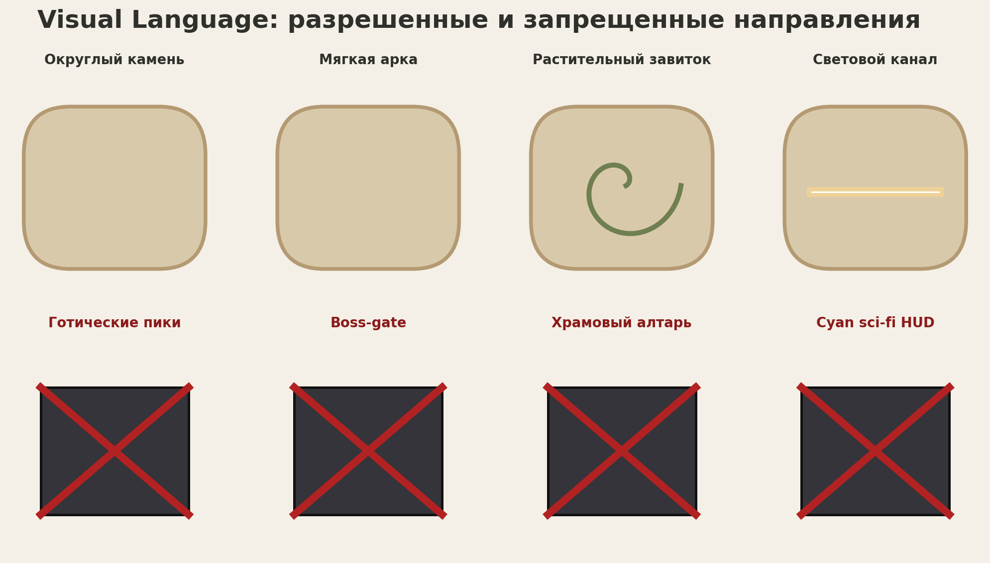
Figure A-A1. Allowed and forbidden visual directions. Text/tables in the source DOCX remain authoritative.
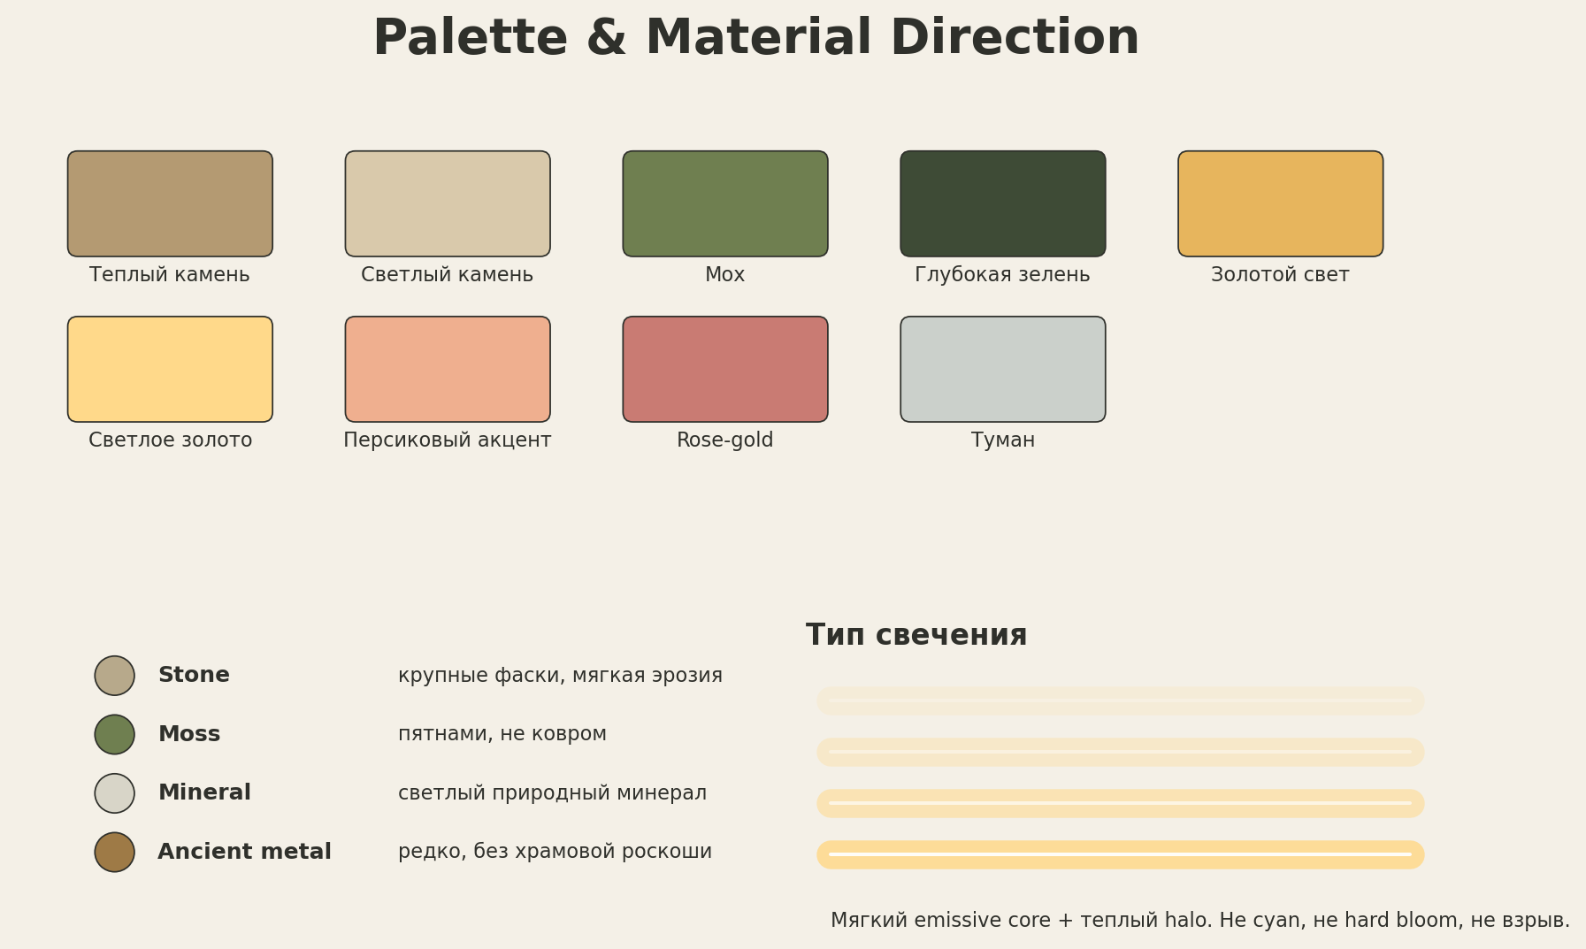
Figure A-A2. Approved palette and material direction.
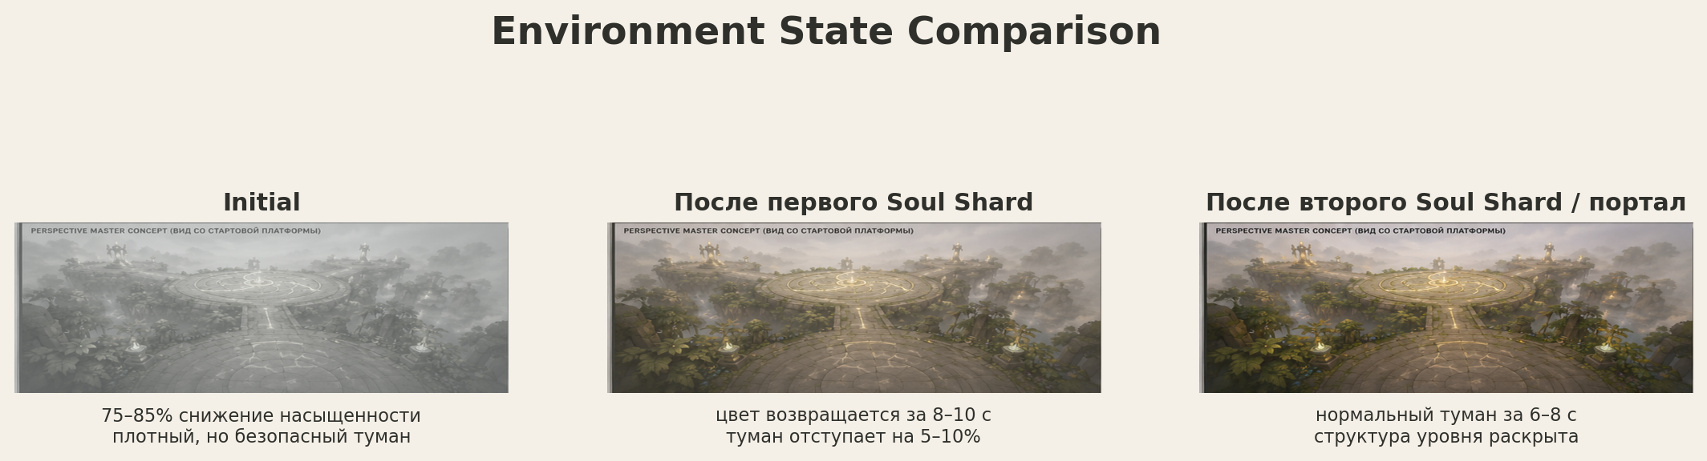
Figure A-A3. Environment-state comparison: initial, first shard and final/portal state.

Appendix B — Production folder map
Area | Canonical path / rule
Blender sources | art/blender/level_02/base | central | trial_a | trial_b | ruins | decor | collision
Raw exports | assets/levels/level_02/base | central | trial_a | trial_b | ruins | decor | collision
Material resources | assets/materials/level_02/ or existing approved material-resource location
Godot wrappers | scenes/environment/level_02/base | central | trial_a | trial_b | ruins | decor
Level block scenes | scenes/levels/level_02/blocks/Block_02_00_CentralArena.tscn through Block_02_04_RoutesAndBoundaries.tscn
Gameplay scenes | scenes/levels/level_02/gameplay/ — unchanged ownership; wrappers are instanced under visual anchors
VFX scenes | scenes/levels/level_02/vfx/ — presentation only; final VFX outside this modeling task
Documentation | docs/design/Level_02_Art_Production_Bible_v1.1.docx after Producer approval

Appendix C — Final production sign-off checklist
Sign-off item | Status
Boundary Map approved with all six route-mouth openings ≥6.0 m and no blockers across channels/corridors | ☐
BASE proxies match exact coordinates/radii/slopes | ☐
Mesh origins verified in Blender and authoritative gameplay pivots verified in Godot | ☐
Collision proxies separated from visual meshes | ☐
Emission surfaces individually addressable | ☐
Art wrappers contain only VisualRoot, approved static collision and ArtAlignment_* aids; gameplay markers/pivots remain gameplay-owned | ☐
Central identities arrival/trial_a/trial_b remain explicit | ☐
Trial B petals independently controllable with positive-scale instances only | ☐
Material family count reviewed; no 4K textures | ☐
Godot import logs clean; no .glb.import manual edits | ☐
Navigation/sightline acceptance repeated after DECOR pass | ☐
Performance and final art acceptance completed | ☐

